**2017级计科和职教PHP2项目说明书**

**一、学号姓名专业：**

学号：2017051603055 专业：计科 姓名： 谭自立 联系电话：17623575750

1. **作业或者项目链接地址**

**注：所有连接地址前面都要有http://，并且录入完链接地址以后还要回车一下，让链接地址城有链接效果（有下划线效果），还要测试一下是不是你链接的网页。出错或者没有链接效果不评分或者得0分。**

1. 平时作业链接地址：<http://wugeng.dev.dxdc.net/p0/index.html>
2. 公告信息栏1链接地址：<http://wugeng.dev.dxdc.net/ggxx/index.php>
3. 公告信息栏2链接地址：<http://wugeng.dev.dxdc.net/ggxxi/index.php>
4. 公告信息栏3链接地址：<http://wugeng.dev.dxdc.net/ggxxiobj/index.php>
5. 公告信息栏4链接地址：<http://wugeng.dev.dxdc.net/ggxxpdo/index.php>
6. Php1项目名称：电子商务平台
7. Php1项目链接地址：<http://wugeng.dev.dxdc.net/php1/index.php>
8. Php2项目名称：图书管理系统
9. Php2项目链接地址：<http://wugeng.dev.dxdc.net/php2/index.php>

**三、大宇服务器FTP服务器参数：**

1. FTP服务器地址：[ftp1.china-dxz.net](ftp://ftp1.china-dxz.net)
2. FTP服务器名称：wugeng
3. FTP服务器密码：A95CD63CEB701a

**四、PHP2项目功能说明**

(200-1000字）

其实图书管理系统在日常生活中也是广泛应用的，比如学校的图书馆、外面的书店等等。这样人民不仅能借到书，也能在网上查询到书，所以有一个图书管理系统也是很有必要的。本项目的设计目标旨在方便图书管理员的操作，减少图书管理员的工作量并使其能更有效的管理书库中的图书，实现了传统的图书管理工作的信息化建设。

管理员：可以查询、添加、删除图书，也能查询、添加、删除读者的信息。

读者：可以查询图书信息、借书、还书、修改自己的信息（主要是登录密码）。

**五、PHP2数据库设计**

1. 画出数据库的E-R图（数据库概念设计）。

(参考群里的三篇13-14级毕业生的毕业论文）

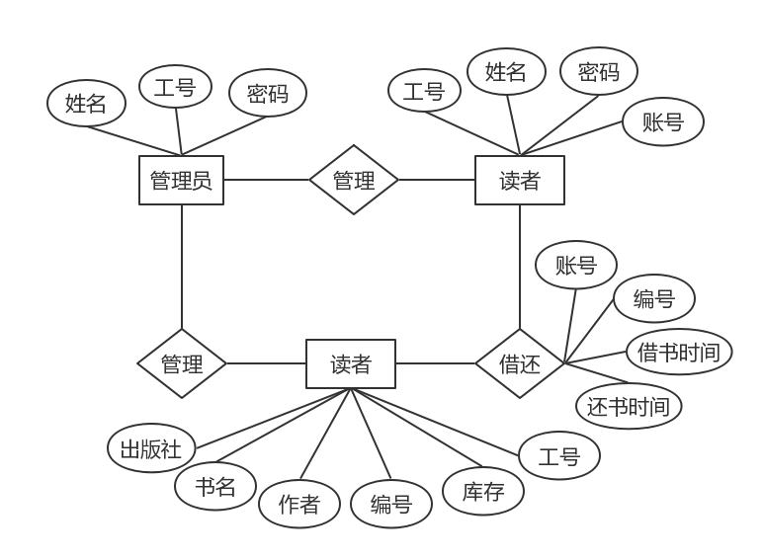

1. 用三线表格填写数据库的逻辑设计

(参考群里的三篇13-14级毕业生的毕业论文）

系统数据库表列表

|  |  |  |  |
| --- | --- | --- | --- |
| 序号 | 表文件名 | 表名称 | 说明 |
| 1 | manager | 管理员列表 | 存储管理员数据 |
| 2 | reader | 读者列表 | 存储读者数据 |
| 3 | book | 书籍列表 | 存储书籍信息数据 |

读者表

|  |  |  |  |  |  |  |  |  |
| --- | --- | --- | --- | --- | --- | --- | --- | --- |
| 序号 | 字段名 | 类型 | 长度 | 默认值 | 主键 | 外键 | 允许为空 | 说明 |
| 1 | reader_id | varchar | 11 | 0 | 是 |  | 否 | 读者ID |
| 2 | reader_name | varchar | 20 | Null |  |  | 否 | 读者昵称 |
| 3 | reader_pwd | varchar | 20 | Null |  |  | 否 | 读者账号 |

管理员表

|  |  |  |  |  |  |  |  |  |
| --- | --- | --- | --- | --- | --- | --- | --- | --- |
| 序号 | 字段名 | 类型 | 长度 | 默认值 | 主键 | 外键 | 允许为空 | 说明 |
| 1 | manager_id | varchar | 10 | 0 | 是 |  | 否 | 管理员ID |
| 2 | manager_name | varchar | 20 | Null |  |  | 否 | 管理员昵称 |
| 3 | manager_pwd | varchar | 20 | Null |  |  | 否 | 管理员账号 |

书籍表

|  |  |  |  |  |  |  |  |  |  |
| --- | --- | --- | --- | --- | --- | --- | --- | --- | --- |
| 序号 | 字段名 | 类型 | 长度 | 默认值 | 主键 | 外键 | | 允许为空 | 说明 |
| 1 | book_id | varchar | 6 | 0 | 是 |  | 否 | | 书籍ID |
| 2 | book_name | varchar | 30 | Null |  |  | 否 | | 书籍名 |
| 3 | book_author | varchar | 20 | Null |  |  | 否 | | 书籍作家 |
| 4 | book_publish | varchar | 20 | Null |  |  | 否 | | 书籍出版社 |
| 5 | book_count | int | 11 | Null |  |  | 否 | | 书籍库存 |

借书表

|  |  |  |  |  |  |  |  |  |  |
| --- | --- | --- | --- | --- | --- | --- | --- | --- | --- |
| 序号 | 字段名 | 类型 | 长度 | 默认值 | 主键 | 外键 | | 允许为空 | 说明 |
| 1 | reader_id | varchar | 11 | 0 | 是 |  | 否 | | 读者ID |
| 2 | book_id | varchar | 10 | 0 | 是 |  | 否 | | 书籍ID |
| 3 | borrow_time | varchar | 10 | Null |  |  | 否 | | 借书时间 |
| 4 | return_time | varchar | 10 | Null |  |  | 否 | | 还书时间 |

1. 数据库物理设计（使用navicat建立数据库和数据表，要把navicat里的数据表窗口图片粘贴出来）。

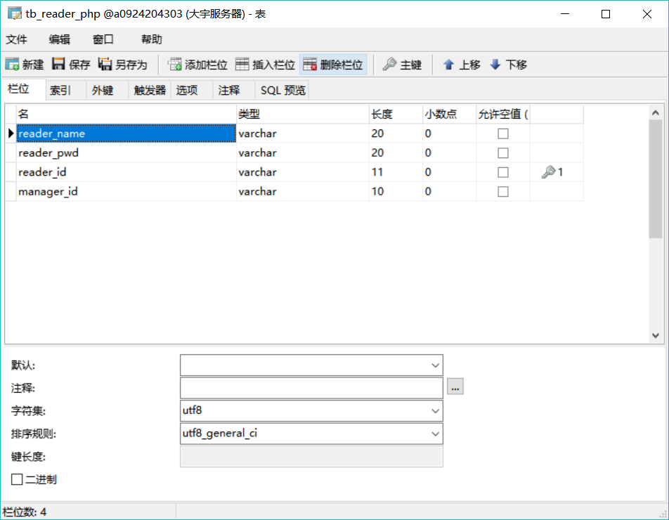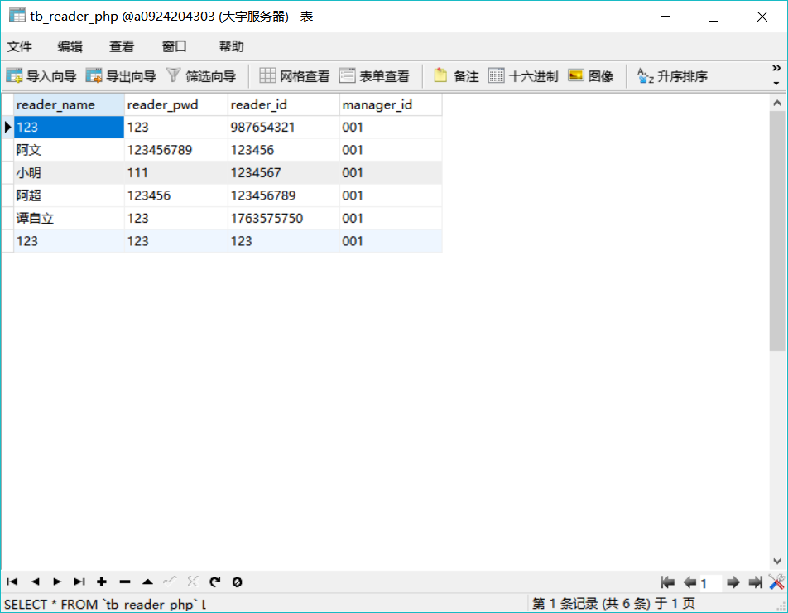

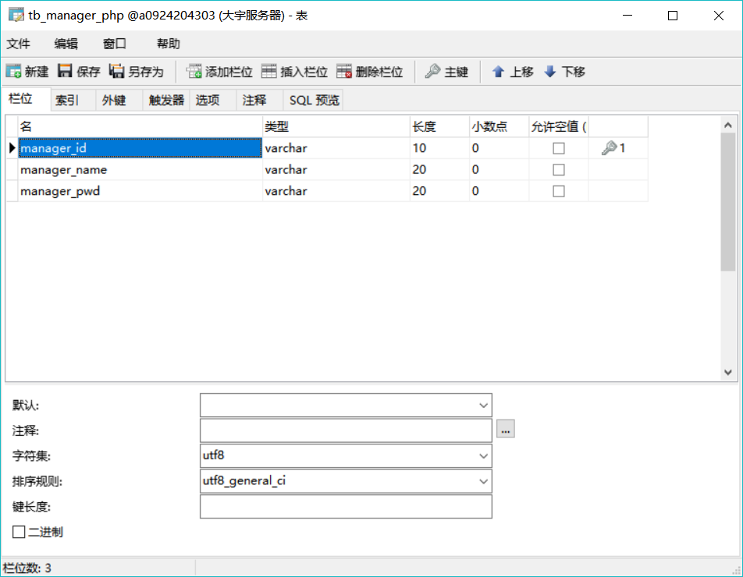

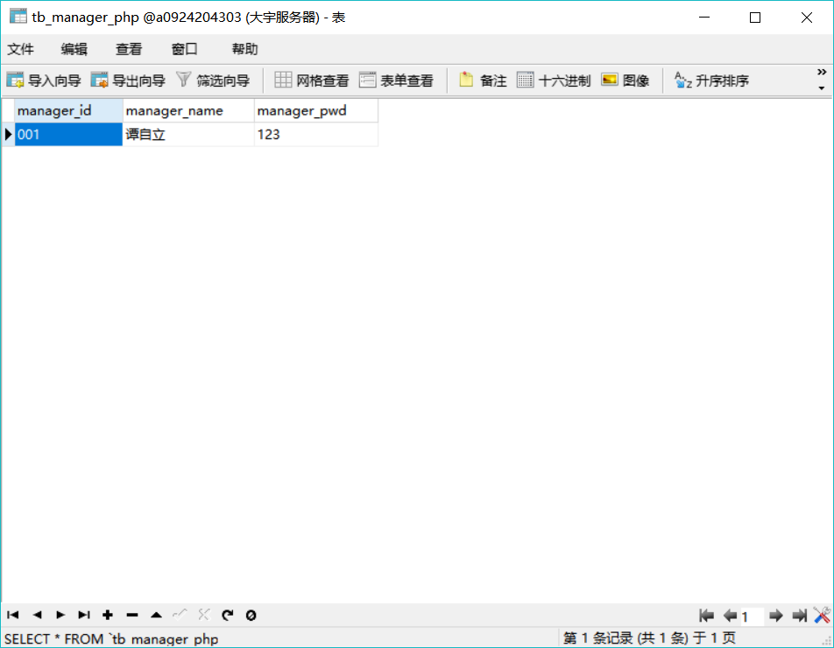

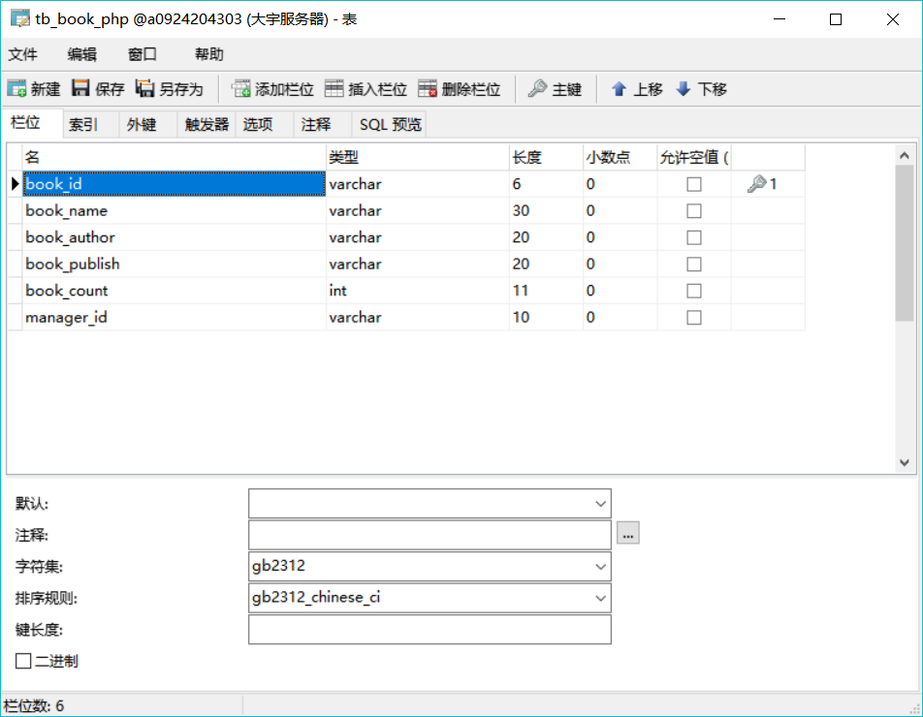

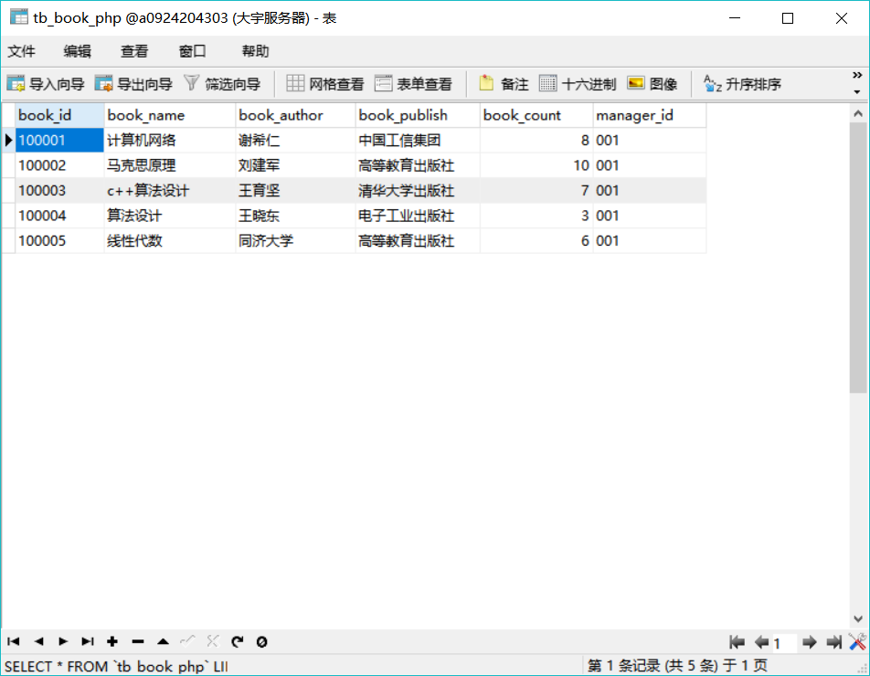

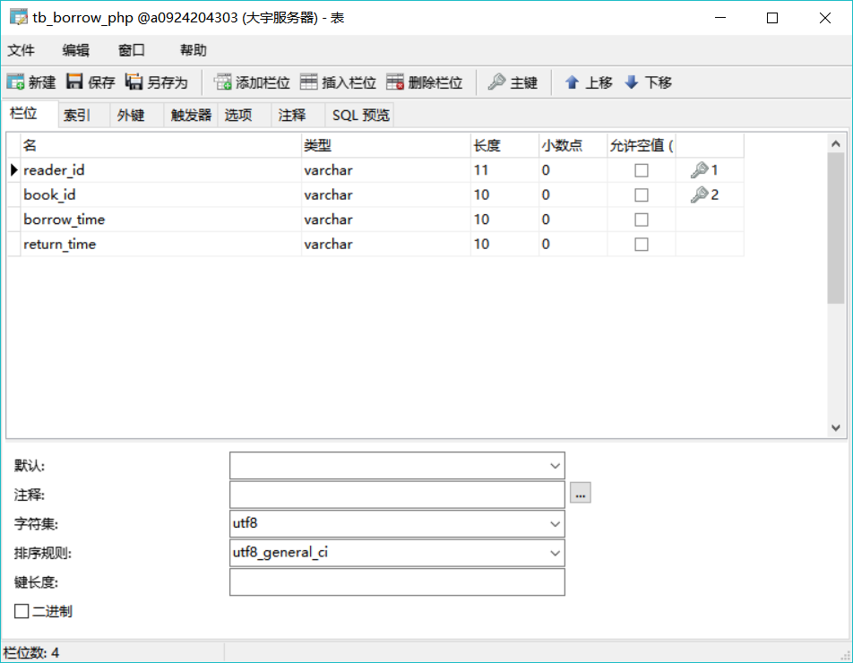

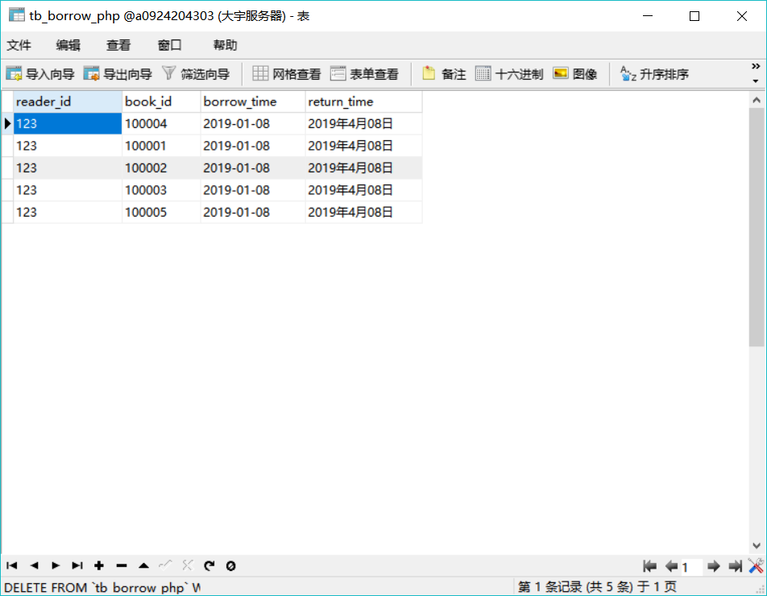

1. 所设计的数据表满足到了第几范式？

第二范式（2NF）

(参考群里的三篇13-14级毕业生的毕业论文，或者查阅数据库方面的图书）

注：后面有例子

**六、学习《web后台技术》课程后的收获体会和建议**

（200-1000字）

人总是这样，当自己还未接触某些东西单单只是看着人家做的时候总是觉得做什么都是简单的，虽然早在上学期做大作业的过程中我就知道自己设计一个好的系统是不容易的，但是直到这学期一个真正好的系统比我之前认为的还要难得多。一个完美的系统需要多方面的努力，不仅要有好的结构模式构思，还要对网站代码非常熟悉与了解，一个完美的系统必定是花费了大量精力和时间的。

对于这学期大作业系统的修改与搭建，我不得不说感触颇多，前前后后花了好多的时间，我不得不承认在做的过程中我没少埋怨，觉得好麻烦又好复杂，有的时候为了调好一个合适颜色都需要测试好久，有时候也有想过要不就随便做一个得了，反正笔试能不能过都还不一定呢，但是这样想吧，心里总是还是有些不安。于是乎就放弃了这个念头，开始琢磨着怎样好属于自己的系统，怎样设计版面又才好看，好不容易的，我终于初步完成了自己的系统搭建，但当我看完其他人做出来的样品后，我感觉自己整个蒙圈，我做的未免也太单一，而且构思也很不丰富，不足的地方实在太多，我自己都不得不否认了自己的作品。

后来，我决定开始重新构思，重新设计版面，一步一步的提前把每一个细节部分都想好，做好一切准备工作后我便重新开始，每天一回到寝室就开电脑（真的是争分多秒）打开DW开始做，真的是着了魔似的，有的时候晚上做得晚了感觉思想都麻木了似的，想的全是系统分析、设计、布局。虽然已经很累了，但是上床后根本睡不着，满脑子想的都是这里怎么调整哪里整么调整，色彩怎么搭配（作为一个对色彩不敏感的人来说搭配颜色真的很痛苦），赶工了好几天，我的系统也大致差不多是完成了，但是还是有些小的bug，说实在的，当我把所有的代码敲完后，我真的觉得调bug才是最痛苦的事，很多的时候你都会觉得你的代码压根就没错，但是效果却也是真的与你想要的不一样，有的时候一个bug都要改好大半天，简直是痛苦得不行，后来遇到一个自己是在调不了的bug还是在室友的帮助下才终于解决了，也真的是不容易。在整个过程中，我用心的去修改每一个不足之处，有时候真的是调代码都有一种调的要哭的感觉，但是不 解决了吧又不甘心，调出来之后也就有一种强烈的满足感。不得不说调代码是一件悲喜交加的事。

最后希望戴老师开恩，我笔试成绩可能不好，大作业我还是认认真真做的，也学到了很多很多，希望不要挂科了，以后要少打游戏认真学习了！！！！

**七、mysql数据库服务器的用户名和密码：**

1、本地虚拟机上的mysql数据库服务器：

用户名： root 密码：

1. 大宇服务器（或者其它远程服务器）上的mysql数据库服务器：

用户名：a0924204303 密码：77477291

**八、数据库名和表名：**

表文件名: tb_manager_php 管理员信息表

tb_reader_php 读者信息表

tb_book_php 书籍信息表

tb_borrow_php 借书信息表

注：如果有多个数据名或者表名，都要分别写清楚。

提醒：数据库名前缀必须是db_

数据表名前缀必须是tb_

不按要求做要扣分。

**九、文件说明**

例如：

1、css文件夹功能说明：网页中所有的样式

2、images 文件夹功能说明：网页中需要用到的图片

conn.php 连接大宇服务器数据库

index.php文件：用户注册

login.php 文件：用户，管理员登陆

reader.php 文件：读者主页

reader_add.php 文件：添加读者

reader_del.php 文件：删除读者

return.php 文件：还书主页

return_ok.php 文件：还书部分

grinformation.php 文件：个人主页信息

book_add.php 文件：添加书籍信息

book_del.php 文件：删除书籍信息

zhuxiao.php 文件：注销用户

borrow_ok.php 文件：借书成功

forget_pwd.php 文件：忘记密码

manager_book.php 文件：管理员主页

manager_pwd_ok.php 文件：管理员信息

hotshare.php文件：修改管理员密码

manager_reader.php 文件：管理员修改读者

modify_pwd_ok.php 文件：读者修改密码

每位同学必须填写自己的PHP2系统的文件说明

**十、界面图片粘贴**

（要对每个界面进行适当说明。如果有登录框，要在登录框上的文本框里显示默认的用户名和密码，或者用“占位符”提示用户名和密码，或者在登录框旁边有注释说明用户名和密码。如果老师无法登记，此作业为0分）用户注册

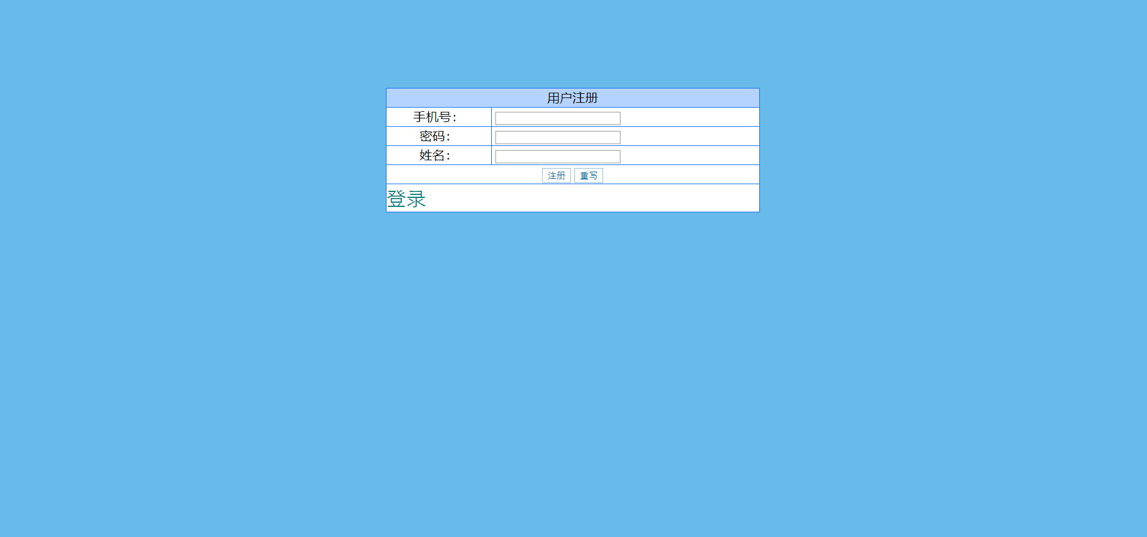

用户登陆

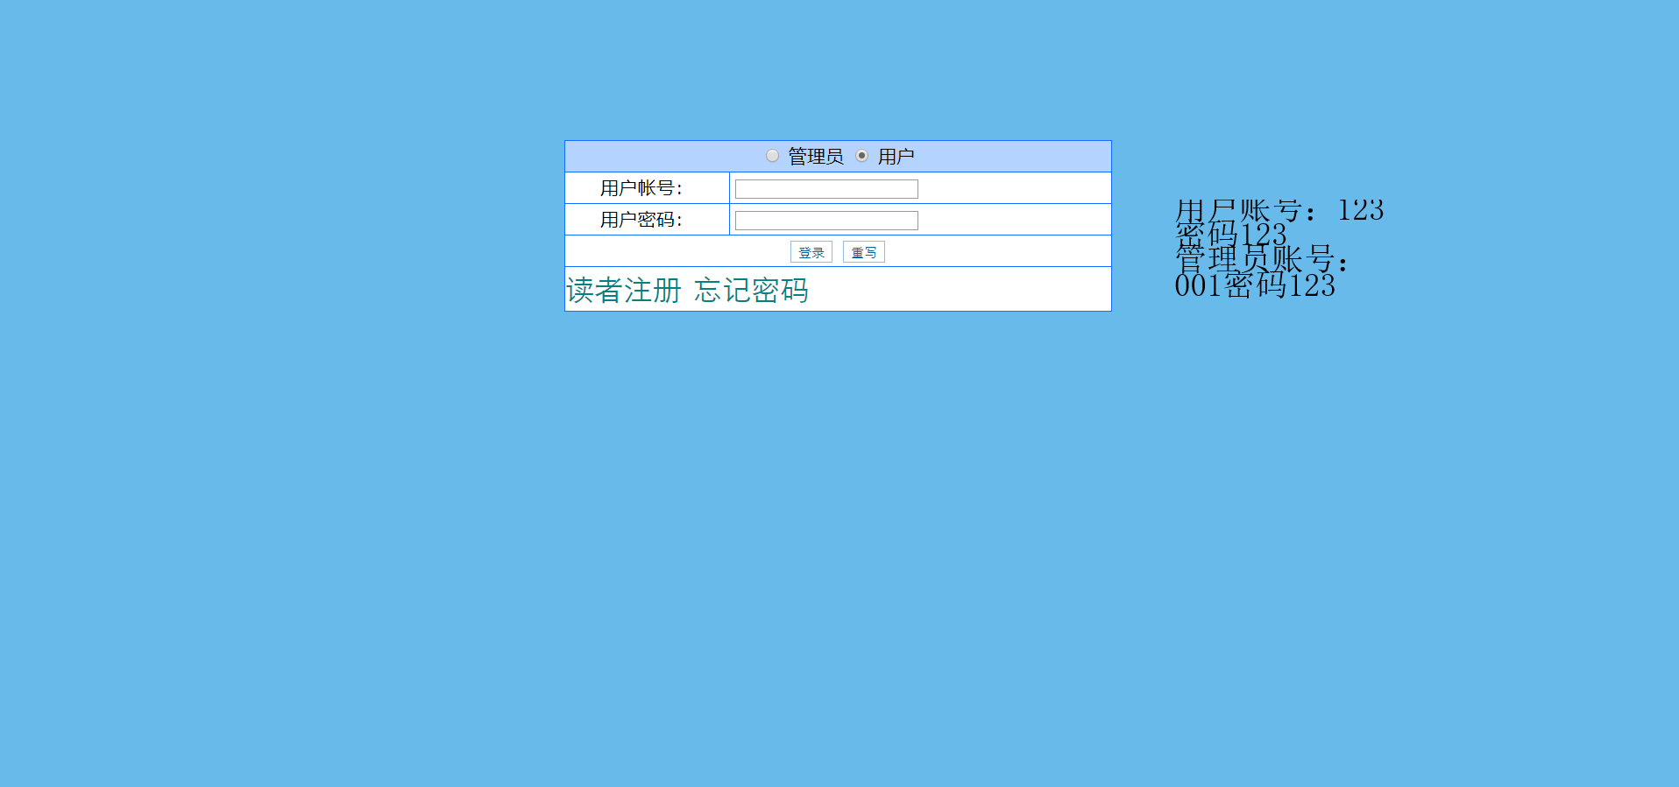

忘记密码

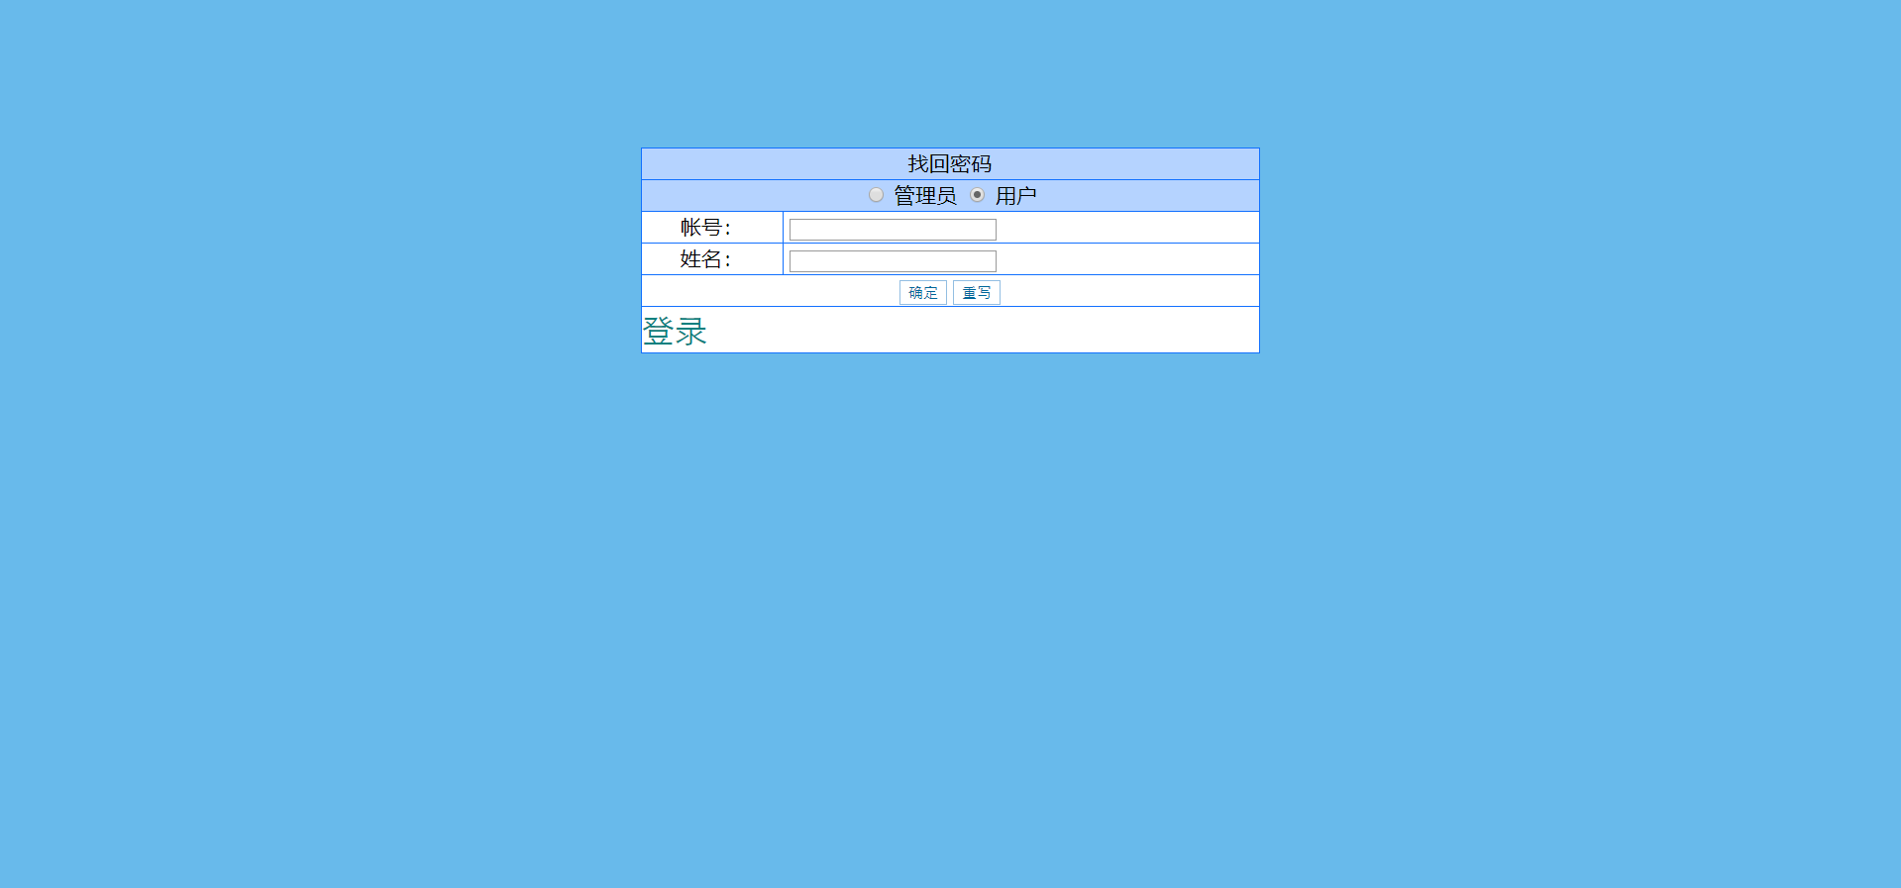

用户主页（借书）

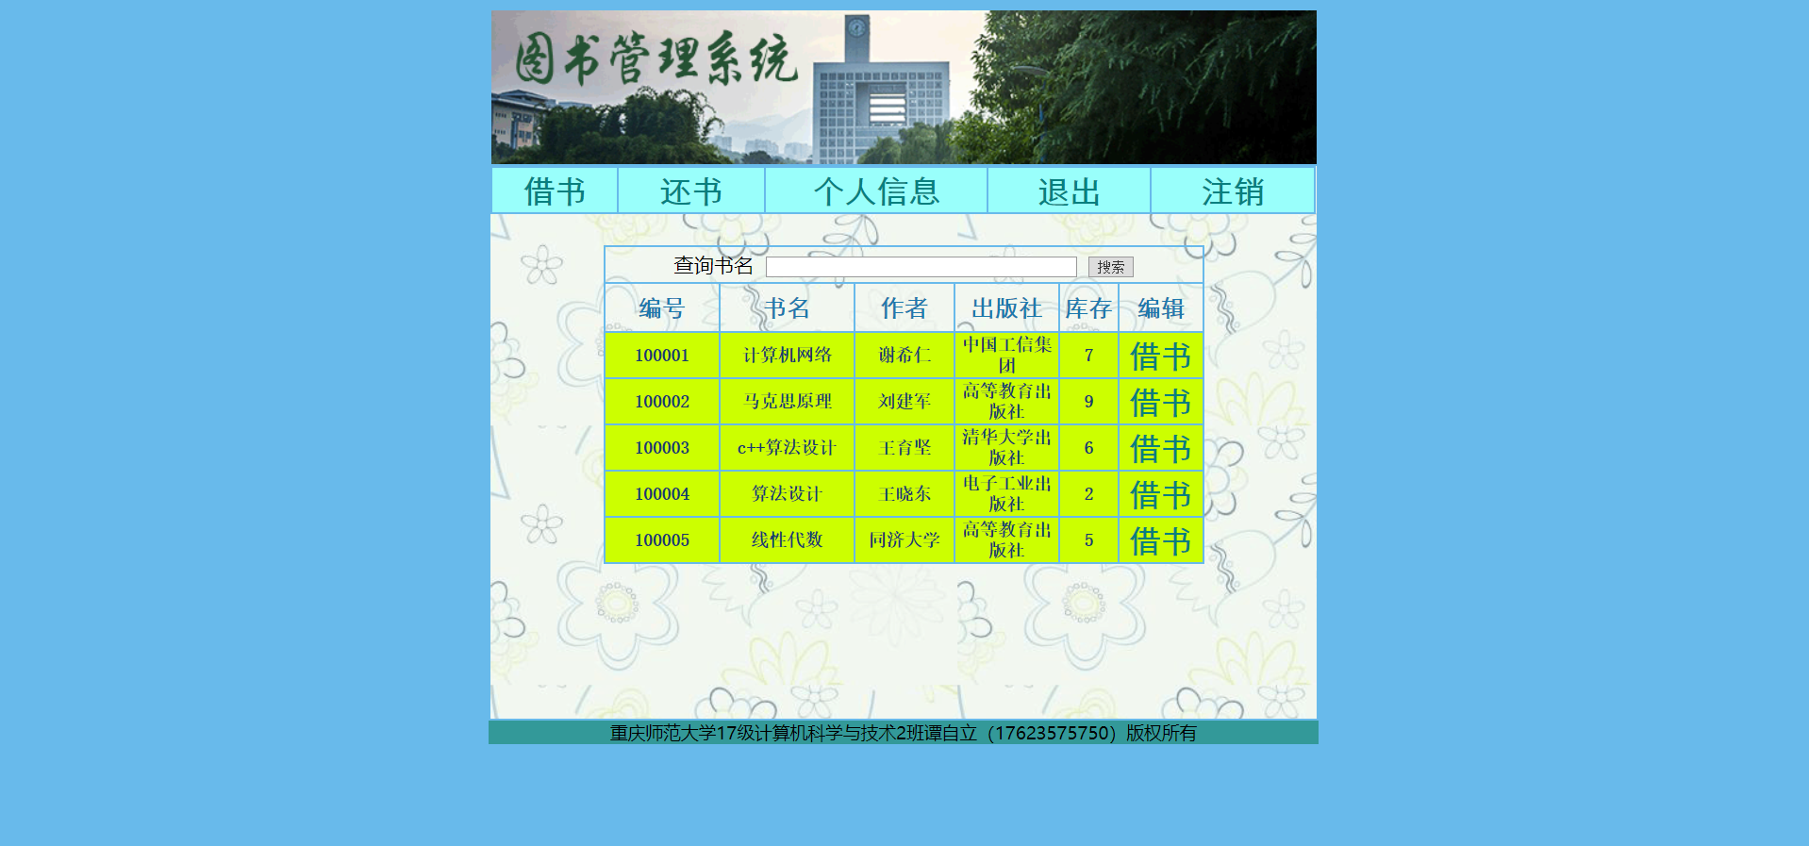

用户还书

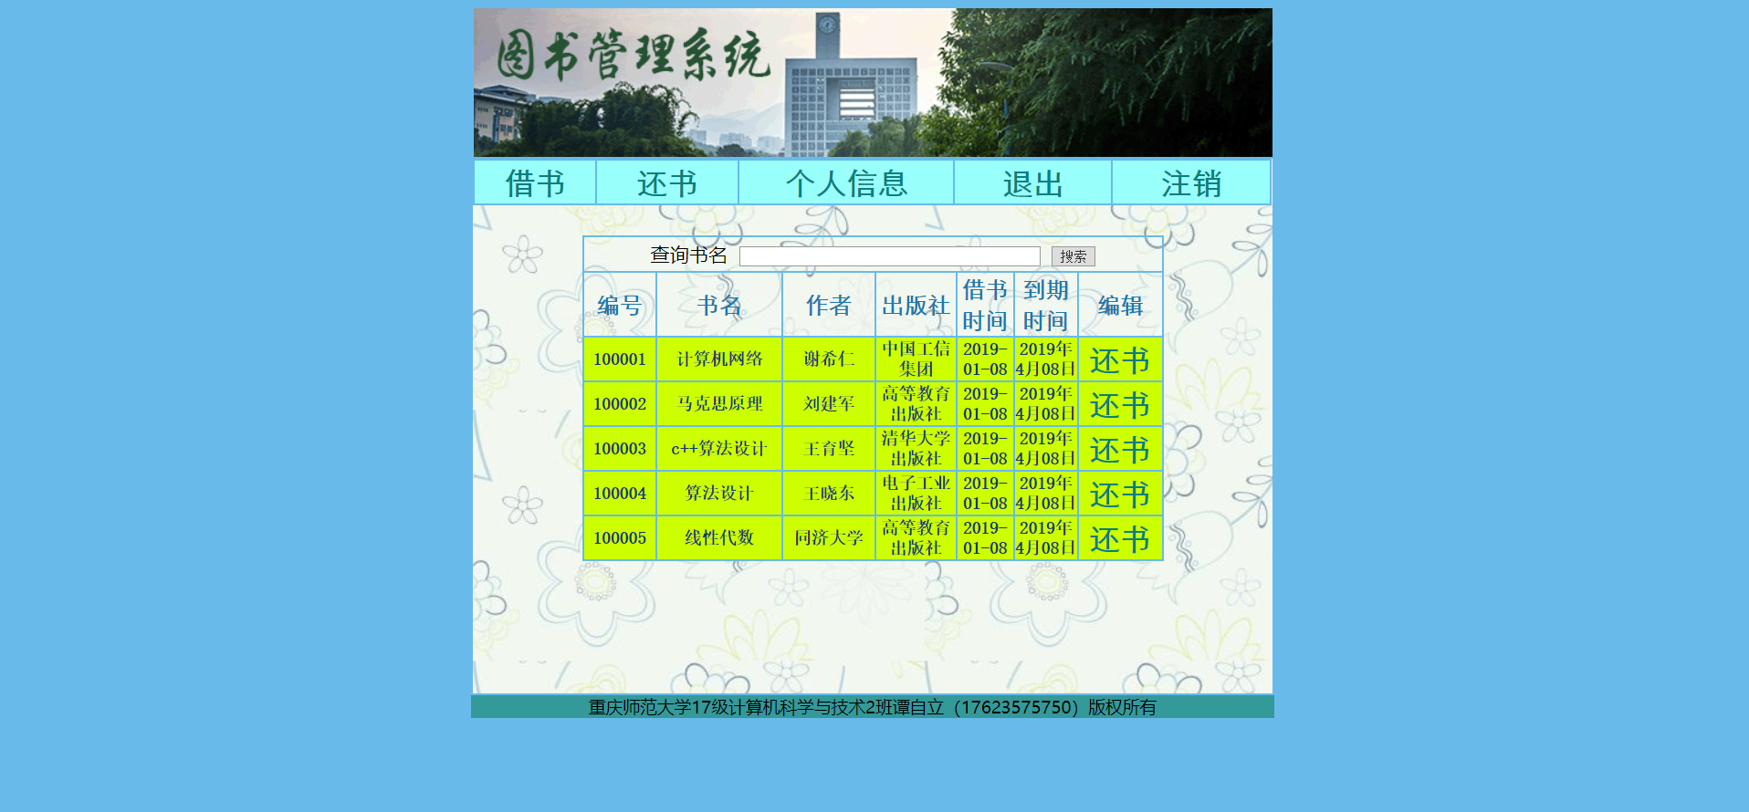

用户个人信息

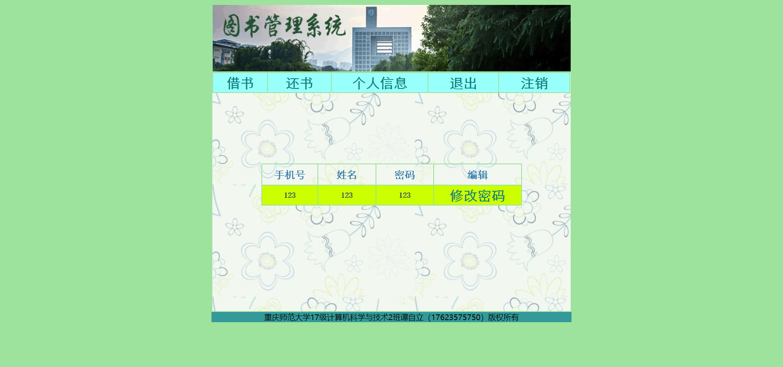

管理员添加书籍

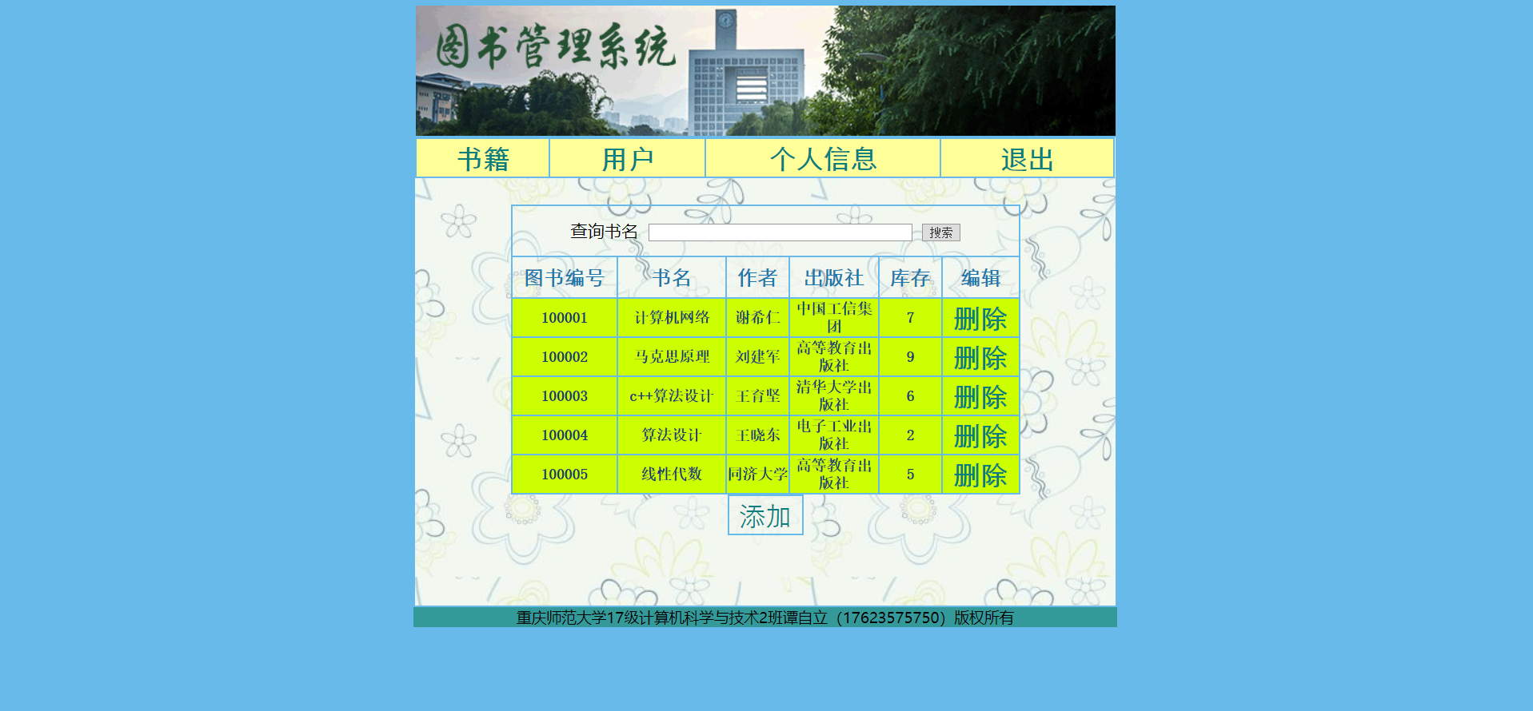

管理员管理用户

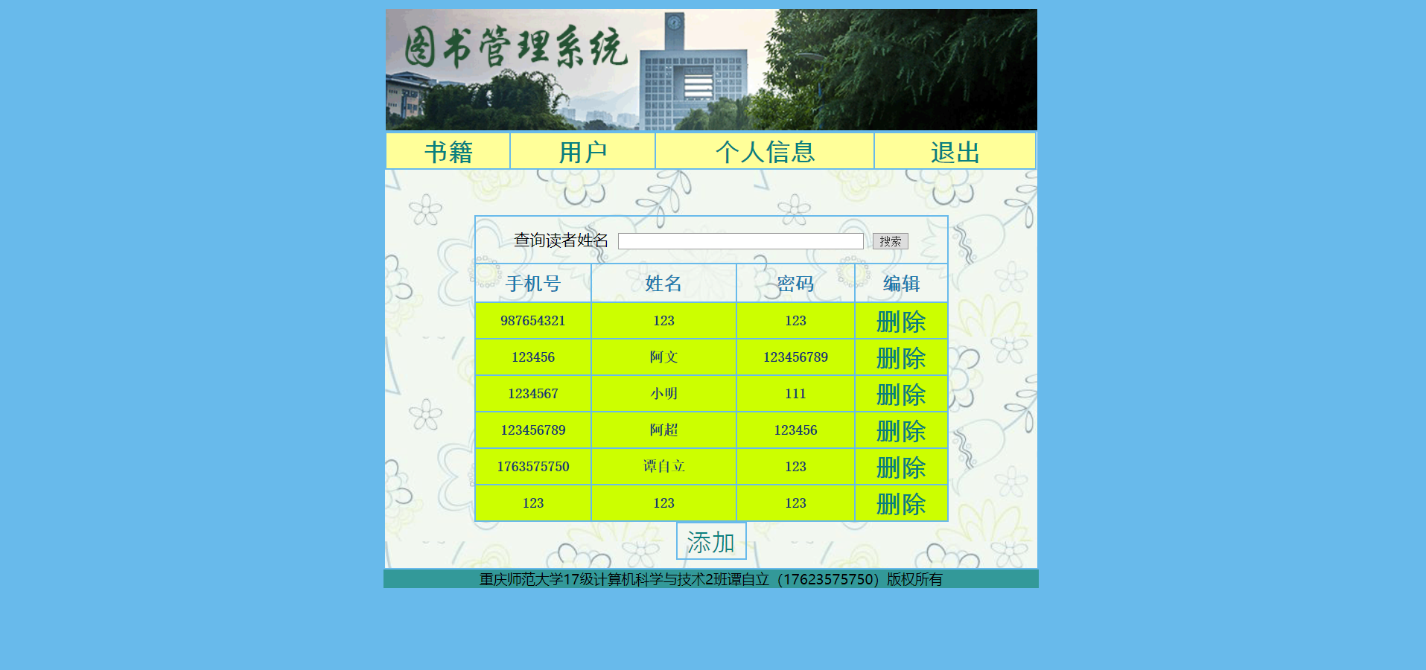

管理员个人信息



修改密码

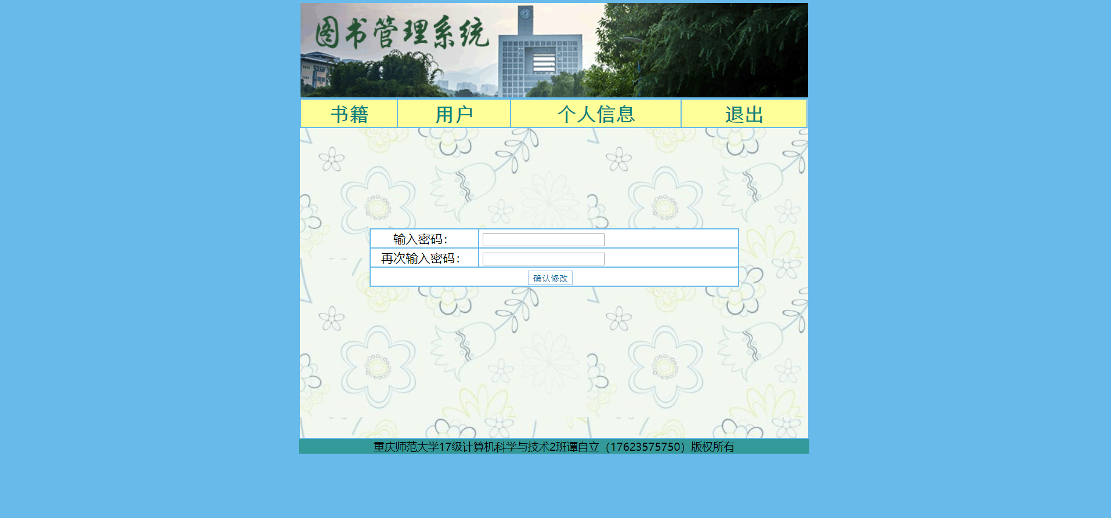

**十一、代码粘贴**

（每个文件代码都要粘贴，在代码粘贴前要写文件名以及此文件的用途。不按要求会扣分）

book_add.php 添加书籍信息

<?php session_start(); ?>

<!DOCTYPE html PUBLIC "-//W3C//DTD XHTML 1.0 Transitional//EN" "http://www.w3.org/TR/xhtml1/DTD/xhtml1-transitional.dtd">

<html xmlns="http://www.w3.org/1999/xhtml">

<head>

<meta http-equiv="Content-Type" content="text/html; charset=utf-8" />

<title>添加书籍信息</title>

<link rel="stylesheet" type="text/css" href="style.css">

</head>

<body bgcolor="#68baeb">

<div align="center">

<table width="700" height="600" border="1" bordercolor="#68baeb" cellpadding="0" cellspacing="0" >

<tr>

<td height="130" width="700" align="center" class="word_green"><img src="images/4.gif" width="700" height="130" /></td>

</tr>

<tr height="470" width="700" valign="top">

<td background="images/bg1.gif">

<table width="700" height="20" border="1" bordercolor="#68baeb"cellpadding="0" cellspacing="0" align="left">

<tr align="left" width="300">

<td width="65" bgcolor="#FFFF99" class="word_orange"><a href="manager_book.php"><strong>书籍</strong></a></td>

<td width="76" bgcolor="#FFFF99" class="word_orange"><a href="manager_reader.php"><strong>用户</strong></a></td>

<td width="115" bgcolor="#FFFF99" class="word_orange"><a href="manager_information.php"><strong>个人信息</strong></a></td>

<td width="84" bgcolor="#FFFF99" class="word_orange"><a href="login.php"><strong>退出</strong></a></td>

</tr>

</table>

<br><br><br><br><br><br><br><br>

<table width="510" height="" border="1" bordercolor="#68baeb" cellpadding="0" cellspacing="0" align="center">

<form name="form1" method="post" action="" onsubmit="return chkinput(this)">

<tr>

<td width="106" height="25" bgcolor="#FFFFFF"><div align="center">图书编号：</div></td>

<td width="275" height="25" bgcolor="#FFFFFF">&nbsp;<input type="text" name="book_id" class="inputcss" size="25">（6位）</td>

</tr>

<tr>

<td height="25" bgcolor="#FFFFFF"><div align="center">书名：</div></td>

<td height="25" bgcolor="#FFFFFF">&nbsp;<input type="text" name="book_name" class="inputcss" size="25"></td>

</tr>

<tr>

<tr>

<td height="25" bgcolor="#FFFFFF"><div align="center">作者：</div></td>

<td height="25" bgcolor="#FFFFFF">&nbsp;<input type="text" name="book_author" class="inputcss" size="25"></td>

</tr>

<tr>

<td height="25" bgcolor="#FFFFFF"><div align="center">出版社：</div></td>

<td height="25" bgcolor="#FFFFFF">&nbsp;<input type="text" name="book_publish" class="inputcss" size="25"></td>

</tr>

<tr>

<td height="25" bgcolor="#FFFFFF"><div align="center">库存：</div></td>

<td height="25" bgcolor="#FFFFFF">&nbsp;<input type="text" name="book_count" class="inputcss" size="25"></td>

</tr>

<tr>

<td height="25" colspan="2" bgcolor="#FFFFFF"><div align="center"><input type="submit" name="submit" value="添加" class="buttoncss" onclick="return check(form1)">&nbsp;&nbsp;</div></td>

</tr>

</form>

<?php

include("conn.php");

$no=$_SESSION['no'];

if(isset($_POST["submit"])){

$book_id=$_POST["book_id"];

$book_name=$_POST["book_name"];

$book_author=$_POST["book_author"];

$book_publish=$_POST["book_publish"];

$book_count=$_POST["book_count"];

$sql=$mysqli->query("select * from tb_book_php where book_id='".$book_id."'");

$row=$sql->fetch_object();

if(!$row){

$result=$mysqli->query("insert into tb_book_php(book_id,book_name,book_author,book_publish,book_count,manager_id) values ('$book_id','$book_name','$book_author','$book_publish','$book_count','$no')");

if($result){

echo "<script>

alert('添加成功！！');

window.location.href='manager_book.php'</script>";

}else{

echo "<script>

alert('添加失败！！');

window.location.href='book_add.php'</script>";

}

}

else{

echo "<script>

alert('图书编号已存在，添加失败！！');

window.location.href='book_add.php'</script>";

}

}

//$result->close();

$mysqli->close();

?>

</table>

</table>

<tr><div id="footer">重庆师范大学17级计算机科学与技术2班谭自立（17623575750）版权所有</div></tr>

</div>

</body>

</html>

book_del.php删除书籍信息

<?php session_start(); ?>

<!DOCTYPE html PUBLIC "-//W3C//DTD XHTML 1.0 Transitional//EN" "http://www.w3.org/TR/xhtml1/DTD/xhtml1-transitional.dtd">

<html xmlns="http://www.w3.org/1999/xhtml">

<head>

<meta http-equiv="Content-Type" content="text/html; charset=utf-8" />

<title>删除书籍信息</title>

</head>

<body>

<?php

include("conn.php");

$id=$_GET["id"];

//$no=$_SESSION["no"];

//var_dump($id);

$sql=$mysqli->query("select * from tb_borrow_php where book_id='".$id."' ");

$row=$sql->fetch_object();

if(!$row){

$query=$mysqli->query("delete from tb_book_php where book_id='".$id."' ");

//var_dump($query);

//$row=$query->fetch_object();

if($query){

echo "<script>

alert('删除书籍成功！！');

window.location.href='manager_book.php'</script>";

}

else{

echo "<script>

alert('删除书籍失败！！');

window.location.href='manager_book.php'</script>";

}

}else{

echo "<script>

alert('这本书还有人没还，不能删除！！');

window.location.href='manager_book.php'</script>";

}

$mysqli->close();

?>

</body>

</html>

borrow_ok.php借书

<?php session_start(); ?>

<!DOCTYPE html PUBLIC "-//W3C//DTD XHTML 1.0 Transitional//EN" "http://www.w3.org/TR/xhtml1/DTD/xhtml1-transitional.dtd">

<html xmlns="http://www.w3.org/1999/xhtml">

<head>

<meta http-equiv="Content-Type" content="text/html; charset=utf-8" />

<title>借书</title>

</head>

<body>

<?php

include("conn.php");

$id=$_GET["id"];

$no=$_SESSION['no'];

//var_dump($id);

//var_dump($no);

$borrow_time=date("Y-m-d");

$y=date('Y');

$m=date('m')+3;

$d=date('d');

if($m>12){

$m=$m-12;

$y=$y+1;

}

$return_time=$y.'年'.$m.'月'.date('d').'日';

//var_dump($borrow_time);

//var_dump($return_time);

$sql=$mysqli->query("select book_count from tb_book_php where book_id='".$id."'");

$row=$sql->fetch_object();

$count=$row->book_count;

//var_dump($count);

if($count==0){

echo "<script>

alert('书已经借完！！');

window.location.href='reader.php'</script>";

}

else{

$sql=$mysqli->query("select * from tb_borrow_php where reader_id='".$no."' and book_id='".$id."'");

$row=$sql->fetch_object();

// var_dump($row);

if($row){echo "<script>

alert('你已经借了这本书！！');

window.location.href='reader.php'</script>";

}else{

$result=$mysqli->query("insert into tb_borrow_php(reader_id,book_id,borrow_time,return_time) values ('$no','$id','$borrow_time','$return_time')");

if($result){

$count=$count-1;

//var_dump($count);

$sql=$mysqli->query("update tb_book_php set book_count='".$count."' where book_id='".$id."'");

echo "<script>

alert('借书成功！！');

window.location.href='reader.php'</script>";

}else{

echo "<script>

alert('借书失败！！');

window.location.href='reader.php?id=<?php echo $id; ?>'</script>";

}

}

}

$mysqli->close();

?>

</body>

</html>

conn.php连接数据库

<!DOCTYPE html PUBLIC "-//W3C//DTD XHTML 1.0 Transitional//EN" "http://www.w3.org/TR/xhtml1/DTD/xhtml1-transitional.dtd">

<html xmlns="http://www.w3.org/1999/xhtml">

<head>

<meta http-equiv="Content-Type" content="text/html; charset=utf-8" />

<title>无标题文档</title>

</head>

<body>

<?php

$mysqli=new mysqli("localhost","a0924204303","77477291","a0924204303",3306)or die("数据库服务器链接错误".$mysqli->error());

$mysqli->query("set names utf8");

?>

</body>

</html>

forget_pwd.php忘记密码

<?php session_start(); ?>

<!DOCTYPE html PUBLIC "-//W3C//DTD XHTML 1.0 Transitional//EN" "http://www.w3.org/TR/xhtml1/DTD/xhtml1-transitional.dtd">

<html xmlns="http://www.w3.org/1999/xhtml">

<head>

<meta http-equiv="Content-Type" content="text/html; charset=utf-8" />

<title>忘记密码</title>

<link rel="stylesheet" type="text/css" href="style.css">

</head>

<script language="javascript">

function chkinput(form){

if(form.no.value==""){

alert("请输入手机号!");

form.no.select();

return(false);

}

if(form.sname.value==""){

alert("请输入姓名!");

form.sname.select();

return(false);

}

}

</script>

<body bgcolor="#68baeb">

<table width="200" border="0" align="center" cellpadding="0" cellspacing="0">

</table>

<br><br><br><br><br>

<table width="500" border="0" align="center" cellpadding="0" cellspacing="0">

<tr>

<td bgcolor="#1170FF"><table width="500" height="157" border="0" align="center" cellpadding="0" cellspacing="1">

<form name="form1" method="post" action="" onsubmit="return chkinput(this)">

<tr>

<td height="25" colspan="2" bgcolor="#B5D3FF"><div align="center">找回密码</div></td>

</tr>

<tr>

<td height="25" colspan="2" bgcolor="#B5D3FF">

<div align="center">

<input name="user" type="radio" value="1" size="6" checked="checked" />

管理员

<input name="user" type="radio" value="2" size="6" checked="checked" />

用户</div>

</td>

</tr>

<tr>

<td height="25" bgcolor="#FFFFFF"><div align="center">帐号：</div></td>

<td height="25" bgcolor="#FFFFFF">&nbsp;<input type="text" name="id" class="inputcss" size="25"></td>

</tr>

<tr>

<td height="25" bgcolor="#FFFFFF"><div align="center">姓名：</div></td>

<td height="25" bgcolor="#FFFFFF">&nbsp;<input type="text" name="name" class="inputcss" size="25"></td>

</tr>

<tr>

<td height="25" colspan="2" bgcolor="#FFFFFF"><div align="center"><input type="submit" name="submit" value="确定" class="buttoncss" onclick="return check(form1)">

<input type="reset" value="重写" class="buttoncss"></div></td>

</tr>

<tr>

<td height="25" colspan="2" bgcolor="#FFFFFF"><a href="login.php">登录</a></td>

</tr>

</form>

</table></td>

</tr>

</table>

<?php

include("conn.php");

if(isset($_POST["submit"])){

$user=$_POST["user"];

}

if(@$user==1){

$id=$_POST["id"];

$name=$_POST["name"];

$result=$mysqli->query("select * from tb_manager_php where manager_id='".$id."' and manager_name='".$name."' ");

$row=$result->fetch_object();

if($row){

$pwd=$row->manager_pwd;

echo "<script>

alert('你的密码是'+$pwd);

window.location.href='login.php'</script>";

}else{

echo "<script>

alert('账号或名字错误，请重新输入！！');

window.location.href='forget_pwd.php'</script>";

}

}

else if(@$user==2){

$id=$_POST["id"];

$name=$_POST["name"];

$sql=$mysqli->query("select * from tb_reader_php where reader_id='".$id."'");

$info=$sql->fetch_object();

if(!$info){

echo "<script>

alert('账号不存在，请先注册');

window.location.href='index.php'</script>";

}else{

$result=$mysqli->query("select * from tb_reader_php where reader_id='".$id."' and reader_name='".$name."' ");

$row=$result->fetch_object();

if($row){

$pwd=$row->reader_pwd;

echo "<script>

alert('你的密码是'+$pwd);

window.location.href='login.php'</script>";

}else{

echo "<script>

alert('名字错误，重新输入！！');

window.location.href='forget_pwd.php'</script>";

}

}

}

$mysqli->close();

?>

</body>

</html>

grinformation.php读者个人信息

<?php session_start(); ?>

<!DOCTYPE html PUBLIC "-//W3C//DTD XHTML 1.0 Transitional//EN" "http://www.w3.org/TR/xhtml1/DTD/xhtml1-transitional.dtd">

<html xmlns="http://www.w3.org/1999/xhtml">

<head>

<meta http-equiv="Content-Type" content="text/html; charset=utf-8" />

<title>个人信息</title>

<link rel="stylesheet" type="text/css" href="style.css">

</head>

<body bgcolor="#9de29d">

<div align="center">

<table width="700" height="600" border="1" bordercolor="#9de29d" cellpadding="0" cellspacing="0" >

<tr>

<td height="130" width="700" align="center" class="word_green"><img src="images/4.gif" width="700" height="130" /></td>

</tr>

<tr height="470" width="700" valign="top">

<td background="images/bg1.gif">

<table width="700" height="20" border="1" bordercolor="#9de29d" cellpadding="0" cellspacing="0" align="left">

<tr align="left" width="300">

<td width="65" bgcolor="#99fffb" class="word_orange"><a href="reader.php"><strong>借书</strong></a></td>

<td width="76" bgcolor="#99fffb" class="word_orange"><a href="return.php"><strong>还书</strong></a></td>

<td width="115" bgcolor="#99fffb" class="word_orange"><a href="grinformation.php"><strong>个人信息</strong></a></td>

<td width="84" bgcolor="#99fffb" class="word_orange"><a href="login.php"><strong>退出</strong></a></td>

<td width="84" bgcolor="#99fffb" class="word_orange"><a href="zhuxiao.php"><strong>注销</strong></a></td>

</tr>

</table>

<br><br><br><br><br><br><br><br>

<table width="510" height="" border="1" bordercolor="#9de29d" cellpadding="0" cellspacing="0" align="center">

<tr align="center" >

<td width="105" height="40" class="word_red"><strong>手机号</strong></td>

<td width="109" height="40" class="word_red"><strong>姓名</strong></td>

<td width="108" height="40" class="word_red"><strong>密码</strong></td>

<td width="165" height="40" class="word_red"><strong>编辑</strong></td>

</tr>

<?php

include("conn.php");

$no=$_SESSION['no'];

//$pwd=$_SESSION['pwd'];

//var_dump($no);

//var_dump($pwd);

$sql=$mysqli->query("select * from tb_reader_php where reader_id='".$no."' ");

$row=$sql->fetch_object();

if(!$row){

echo"<font color='red'>没有你的个人信息！！</font>";

}else{

do{

?>

<tr bgcolor="#CCFF00" align="center" class="word_black">

<td class="word_black" height="30"><strong><?php echo $row->reader_id; ?></strong></td>

<td class="word_black" height="30"><strong><?php echo $row->reader_name; ?></strong></td>

<td class="word_black" height="30"><strong><?php echo $row->reader_pwd; ?></strong></td>

<td class="word_black" height="30"><strong><a href="modify_pwd_ok.php">修改密码</a></strong></td>

</tr>

<?php

}while($row=$sql->fetch_object());

}

$sql->close();

$mysqli->close();

?>

</table>

</td>

</tr>

</table>

<tr><div id="footer">重庆师范大学17级计算机科学与技术2班谭自立（17623575750）版权所有</div></tr>

</div>

</body>

</html>

index.php 用户注册

<?php session_start(); ?>

<!DOCTYPE html PUBLIC "-//W3C//DTD XHTML 1.0 Transitional//EN" "http://www.w3.org/TR/xhtml1/DTD/xhtml1-transitional.dtd">

<html xmlns="http://www.w3.org/1999/xhtml">

<head>

<meta http-equiv="Content-Type" content="text/html; charset=utf-8" />

<title>用户注册</title>

<link rel="stylesheet" type="text/css" href="style.css">

</head>

<script language="javascript">

function chkinput(form){

if(form.no.value==""){

alert("请输入手机号!");

form.no.select();

return(false);

}

if(form.pwd.value==""){

alert("请输入密码!");

form.pwd.select();

return(false);

}

if(form.sname.value==""){

alert("请输入姓名!");

form.sname.select();

return(false);

}

}

</script>

<body bgcolor="#68baeb">

<table width="200" border="0" align="center" cellpadding="0" cellspacing="0">

</table>

<br><br><br><br><br>

<table width="500" border="0" align="center" cellpadding="0" cellspacing="0">

<tr>

<td bgcolor="#1170FF"><table width="500" height="157" border="0" align="center" cellpadding="0" cellspacing="1">

<form name="form1" method="post" action="" onsubmit="return chkinput(this)">

<tr>

<td height="25" colspan="2" bgcolor="#B5D3FF"><div align="center">用户注册</div></td>

</tr>

<tr>

<td height="25" bgcolor="#FFFFFF"><div align="center">手机号：</div></td>

<td height="25" bgcolor="#FFFFFF">&nbsp;<input type="text" name="id" class="inputcss" size="25"></td>

</tr>

<tr>

<td height="25" bgcolor="#FFFFFF"><div align="center">密码：</div></td>

<td height="25" bgcolor="#FFFFFF">&nbsp;<input type="password" name="pwd" class="inputcss" size="25"></td>

</tr>

<tr>

<td height="25" bgcolor="#FFFFFF"><div align="center">姓名：</div></td>

<td height="25" bgcolor="#FFFFFF">&nbsp;<input type="text" name="name" class="inputcss" size="25"></td>

</tr>

<tr>

<td height="25" colspan="2" bgcolor="#FFFFFF"><div align="center"><input type="submit" name="submit" value="注册" class="buttoncss" onclick="return check(form1)">

<input type="reset" value="重写" class="buttoncss"></div></td>

</tr>

<tr>

<td height="25" colspan="2" bgcolor="#FFFFFF"><a href="login.php">登录</a></td>

</tr>

</form>

</table></td>

</tr>

</table>

<?php

include("conn.php");

if(isset($_POST["submit"])){

$id=$_POST["id"];

$pwd=$_POST["pwd"];

$name=$_POST["name"];

$result=$mysqli->query("insert into tb_reader_php(reader_id,reader_name,reader_pwd,manager_id) values ('$id','$name','$pwd','001')");

if($result){

echo "<script>

alert('注册成功！！');

window.location.href='login.php'</script>";

}else{

echo "<script>

alert('手机号已注册，可直接登录！！');

window.location.href='login.php'</script>";

}

}

$mysqli->close();

?>

</body>

</html>

login.php用户，管理员登陆

<?php session_start(); ?>

<!DOCTYPE html PUBLIC "-//W3C//DTD XHTML 1.0 Transitional//EN" "http://www.w3.org/TR/xhtml1/DTD/xhtml1-transitional.dtd">

<html xmlns="http://www.w3.org/1999/xhtml">

<head>

<meta http-equiv="Content-Type" content="text/html; charset=utf-8" />

<title>用户登录</title>

<link rel="stylesheet" type="text/css" href="style.css">

</head>

<body bgcolor="#68baeb">

<script language="javascript">

function chkinput(form){

if(form.no.value==""){

alert("请输入帐号!");

form.no.select();

return(false);

}

if(form.pwd.value==""){

alert("请输入登录密码!");

form.pwd.select();

return(false);

}

}

</script>

<table width="500" height="10" border="0" align="center" cellpadding="0" cellspacing="0">

</table>

<br><br><br><br><br>

<table width="500" border="0" align="center" cellpadding="0" cellspacing="0">

<tr>

<td bgcolor="#1170FF"><table width="500" height="157" border="0" align="center" cellpadding="0" cellspacing="1">

<form name="form2" method="post" action="" onsubmit="return chkinput(this)">

<tr>

<td height="25" colspan="2" bgcolor="#B5D3FF">

<div align="center">

<input name="user" type="radio" value="1" size="6" checked="checked" />

管理员

<input name="user" type="radio" value="2" size="6" checked="checked" />

用户</div>

</td>

</tr>

<tr>

<td width="150" height="25" bgcolor="#FFFFFF"><div align="center">用户帐号：</div></td>

<td width="347" bgcolor="#FFFFFF">&nbsp;<input type="text" name="no" class="inputcss" size="25"></td>

</tr>

<tr>

<td height="25" bgcolor="#FFFFFF"><div align="center">用户密码：</div></td>

<td height="25" bgcolor="#FFFFFF">&nbsp;<input type="password" name="pwd" class="inputcss" size="25"></td>

</tr>

<tr>

<td height="25" colspan="2" bgcolor="#FFFFFF"><div align="center"><input type="submit" name="submit" value="登录" class="buttoncss" onclick="return check(form2)">&nbsp;&nbsp;<input type="reset" value="重写" class="buttoncss"></div></td>

</tr>

<tr>

<td height="25" colspan="2" bgcolor="#FFFFFF"><a href="index.php">读者注册</a>&nbsp;&nbsp;<a href="forget_pwd.php">忘记密码</a></td>

</tr>

</form>

</table></td>

</tr>

</table>

<?php

include("conn.php");

if(isset($_POST["submit"])){

$user=$_POST["user"];

}

if(@$user==1){

$no=$_POST["no"];

$pwd=$_POST["pwd"];

$sql=$mysqli->query("select * from tb_manager_php where manager_id='".$no."' ");

$info=$sql->fetch_object();

if($info){

$password1=$info->manager_pwd;

if($pwd==$password1){

echo "<script>

alert('登录成功！！');

window.location.href='manager_book.php'</script>";

$_SESSION['no']=$info->manager_id;

$_SESSION['pwd']=$info->manager_pwd;

}else{

echo "<script>

alert('密码有误，请重新输入！！');

window.location.href='login.php'</script>";

}

}else{echo "<script>

alert('账号不存在！！');

</script>";}

}

else if(@$user==2){

$tel=$_POST["no"];

$pwd=$_POST["pwd"];

//$sql=$mysqli->query("select * from tb_reader_php where

// reader_tel='".$tel."' and reader_pwd='".$pwd."' ");

$sql=$mysqli->query("select * from tb_reader_php where reader_id='".$tel."' ");

$info=$sql->fetch_object();

if($info){

$password=$info->reader_pwd;

if($pwd==$password){

echo "<script>

alert('登录成功！！');

window.location.href='reader.php'</script>";

$_SESSION['no']=$info->reader_id;

$_SESSION['pwd']=$info->reader_pwd;

}else{

echo "<script>

alert('密码有误，请重新输入！！');

window.location.href='login.php'</script>";

}

}else{echo "<script>

alert('账号不存在，请先注册！！');

window.location.href='index.php'</script>";}

}

$mysqli->close();

?>

</body>

</html>

manager_book.php管理员管理图书

<?php session_start(); ?>

<!DOCTYPE html PUBLIC "-//W3C//DTD XHTML 1.0 Transitional//EN" "http://www.w3.org/TR/xhtml1/DTD/xhtml1-transitional.dtd">

<html xmlns="http://www.w3.org/1999/xhtml">

<head>

<meta http-equiv="Content-Type" content="text/html; charset=utf-8" />

<title>管理员</title>

<link rel="stylesheet" type="text/css" href="style.css">

</head>

<body bgcolor="#68baeb">

<div align="center">

<table width="700" height="600" border="1" bordercolor="#68baeb" cellpadding="0" cellspacing="0" >

<tr>

<td height="130" width="700" align="center" class="word_green"><img src="images/4.gif" width="700" height="130" /></td>

</tr>

<tr height="470" width="700" valign="top">

<td background="images/bg1.gif">

<table width="700" height="20" border="1" bordercolor="#68baeb" cellpadding="0" cellspacing="0" align="left">

<tr align="left" width="300">

<td width="65" bgcolor="#FFFF99" class="word_orange"><a href="manager_book.php"><strong>书籍</strong></a></td>

<td width="76" bgcolor="#FFFF99" class="word_orange"><a href="manager_reader.php"><strong>用户</strong></a></td>

<td width="115" bgcolor="#FFFF99" class="word_orange"><a href="manager_information.php"><strong>个人信息</strong></a></td>

<td width="84" bgcolor="#FFFF99" class="word_orange"><a href="login.php"><strong>退出</strong></a></td>

</tr>

</table>

<br><br><br>

<table width="510" height="" border="1" bordercolor="#68baeb" cellpadding="0" cellspacing="0" align="center">

<tr height="30">

<td height="50" align="center" colspan="6">

<form action="" name="form1" method="post">查询书名&nbsp;

<input type="text" name="txt_keyword" id="txt_keyword" size="40">&nbsp;

<input type="submit" name="Submit" value="搜索" onclick="return check(form)">

</form>

</td>

</tr>

<tr align="center" height="40">

<td width="100" height="40" class="word_red"><strong>图书编号</strong></td>

<td width="103" height="40" class="word_red"><strong>书名</strong></td>

<td width="59" height="40" class="word_red"><strong>作者</strong></td>

<td width="84" height="40" class="word_red"><strong>出版社</strong></td>

<td width="59" height="40" class="word_red"><strong>库存</strong></td>

<td width="72" height="40" class="word_red"><strong>编辑</strong></td>

</tr>

<?php

include("conn.php");

//$no=$_SESSION['no'];

$sql=$mysqli->query("select * from tb_book_php");

$row=$sql->fetch_object();

if(!$row){

echo"<font color='red'>暂时没有书籍！！</font>";

}else{

if(isset($_POST["Submit"])){

$keyword=$_POST["txt_keyword"];

$sql=$mysqli->query("select * from tb_book_php where book_name like '%$keyword%'");

$row=$sql->fetch_object();

}

if(!$row){

echo"<font color='red'>没有这本书！！</font>";

}else{

do{

?>

<tr bgcolor="#CCFF00" align="center" class="word_black" height="30">

<td class="word_black" height="30"><strong><?php echo $row->book_id; ?></strong></td>

<td class="word_black" height="30"><strong><?php echo $row->book_name; ?></strong></td>

<td class="word_black" height="30"><strong><?php echo $row->book_author; ?></strong></td>

<td class="word_black" height="30"><strong><?php echo $row->book_publish; ?></strong></td>

<td class="word_black" height="30"><strong><?php echo $row->book_count; ?></strong></td>

<td class="word_black" height="30"><strong><a href="book_del.php?id=<?php echo $row->book_id; ?>">删除</a></strong></td>

</tr>

<?php

}while($row=$sql->fetch_object());

}

}

$sql->close();

$mysqli->close();

?>

</table>

<table width="76" height="30" border="1" bordercolor="#68baeb" cellpadding="0" cellspacing="0" align="center">

<tr>

<td width="68" height="30" class="word_red" align="center"><a href="book_add.php">添加</a></td>

</tr>

</table>

</td>

</tr>

</table>

<tr><div id="footer">重庆师范大学17级计算机科学与技术2班谭自立（17623575750）版权所有</div></tr>

</div>

</body>

</html>

manager_information.php管理员信息

<?php session_start(); ?>

<!DOCTYPE html PUBLIC "-//W3C//DTD XHTML 1.0 Transitional//EN" "http://www.w3.org/TR/xhtml1/DTD/xhtml1-transitional.dtd">

<html xmlns="http://www.w3.org/1999/xhtml">

<head>

<meta http-equiv="Content-Type" content="text/html; charset=utf-8" />

<title>管理员信息</title>

<link rel="stylesheet" type="text/css" href="style.css">

</head>

<body bgcolor="#68baeb">

<div align="center">

<table width="700" height="600" border="1" bordercolor="#68baeb" cellpadding="0" cellspacing="0" >

<tr>

<td height="130" width="700" align="center" class="word_green"><img src="images/4.gif" width="700" height="130" /></td>

</tr>

<tr height="470" width="700" valign="top">

<td background="images/bg1.gif">

<table width="700" height="20" border="1" bordercolor="#68baeb" cellpadding="0" cellspacing="0" align="left">

<tr align="left" width="300">

<td width="65" bgcolor="#FFFF99" class="word_orange"><a href="manager_book.php"><strong>书籍</strong></a></td>

<td width="76" bgcolor="#FFFF99" class="word_orange"><a href="manager_reader.php"><strong>用户</strong></a></td>

<td width="115" bgcolor="#FFFF99" class="word_orange"><a href="manager_information.php"><strong>个人信息</strong></a></td>

<td width="84" bgcolor="#FFFF99" class="word_orange"><a href="login.php"><strong>退出</strong></a></td>

</tr>

</table>

<br><br><br><br><br><br><br><br>

<table width="510" height="" border="1" bordercolor="#68baeb" cellpadding="0" cellspacing="0" align="center">

<tr align="center" >

<td width="105" height="40" class="word_red"><strong>工号</strong></td>

<td width="109" height="40" class="word_red"><strong>姓名</strong></td>

<td width="108" height="40" class="word_red"><strong>密码</strong></td>

<td width="165" height="40" class="word_red"><strong>编辑</strong></td>

</tr>

<?php

include("conn.php");

$no=$_SESSION['no'];

$sql=$mysqli->query("select * from tb_manager_php");

$row=$sql->fetch_object();

if(!$row){

echo"<font color='red'>没有个人信息！！</font>";

}else{

do{

?>

<tr bgcolor="#CCFF00" align="center" class="word_black">

<td class="word_black" height="30"><strong><?php echo $row->manager_id; ?></strong></td>

<td class="word_black" height="30"><strong><?php echo $row->manager_name; ?></strong></td>

<td class="word_black" height="30"><strong><?php echo $row->manager_pwd; ?></strong></td>

<td class="word_black" height="30"><strong><a href="manager_pwd_ok.php">修改密码</a></strong></td>

</tr>

<?php

}while($row=$sql->fetch_object());

}

$sql->close();

$mysqli->close();

?>

</table>

</td>

</tr>

</table>

<tr><div id="footer">重庆师范大学17级计算机科学与技术2班谭自立（17623575750）版权所有</div></tr>

</div>

</body>

</html>

manager_pwd_ok.php管理员修改密码

<?php session_start(); ?>

<!DOCTYPE html PUBLIC "-//W3C//DTD XHTML 1.0 Transitional//EN" "http://www.w3.org/TR/xhtml1/DTD/xhtml1-transitional.dtd">

<html xmlns="http://www.w3.org/1999/xhtml">

<head>

<meta http-equiv="Content-Type" content="text/html; charset=utf-8" />

<title>修改管理员密码</title>

<link rel="stylesheet" type="text/css" href="style.css">

</head>

<body bgcolor="#68baeb">

<div align="center">

<table width="700" height="600" border="1" bordercolor="#68baeb" cellpadding="0" cellspacing="0" >

<tr>

<td height="130" width="700" align="center" class="word_green"><img src="images/4.gif" width="700" height="130" /></td>

</tr>

<tr height="470" width="700" valign="top">

<td background="images/bg1.gif">

<table width="700" height="20" border="1" bordercolor="#68baeb" cellpadding="0" cellspacing="0" align="left">

<tr align="left" width="300">

<td width="65" bgcolor="#FFFF99" class="word_orange"><a href="manager_book.php"><strong>书籍</strong></a></td>

<td width="76" bgcolor="#FFFF99" class="word_orange"><a href="manager_reader.php"><strong>用户</strong></a></td>

<td width="115" bgcolor="#FFFF99" class="word_orange"><a href="manager_information.php"><strong>个人信息</strong></a></td>

<td width="84" bgcolor="#FFFF99" class="word_orange"><a href="login.php"><strong>退出</strong></a></td>

</tr>

</table>

<br><br><br><br><br><br><br><br>

<table width="510" height="" border="1" bordercolor="#68baeb" cellpadding="0" cellspacing="0" align="center">

<form name="form1" method="post" action="" onsubmit="return chkinput(this)">

<tr>

<td width="122" height="25" bgcolor="#FFFFFF"><div align="center">输入密码：</div></td>

<td width="295" height="25" bgcolor="#FFFFFF">&nbsp;<input type="password" name="password1" class="inputcss" size="25"></td>

</tr>

<tr>

<td height="25" bgcolor="#FFFFFF"><div align="center">再次输入密码：</div></td>

<td height="25" bgcolor="#FFFFFF">&nbsp;<input type="password" name="password2" class="inputcss" size="25"></td>

</tr>

<tr>

<td height="25" colspan="2" bgcolor="#FFFFFF"><div align="center"><input type="submit" name="submit" value="确认修改" class="buttoncss" onclick="return check(form1)">&nbsp;&nbsp;</div></td>

</tr>

</form>

<?php

include("conn.php");

$no=$_SESSION['no'];

$pwd=$_SESSION['pwd'];

//var_dump($no);

//$id=$_GET["id"];

//var_dump($pwd);

if(isset($_POST["submit"])){

$password1=$_POST["password1"];

$password2=$_POST["password2"];

if($password1==$password2){

//var_dump($password1);

if($password1==$pwd){echo "<script>

alert('和原密码相同！！');

window.location.href='manager_pwd_ok.php'</script>";

}else{

$result=$mysqli->query("update tb_manager_php set manager_pwd='".$password1."' where manager_id='".$no."' ");

//var_dump($result);

if($result){

echo "<script>

alert('修改成功！！');

window.location.href='manager_information.php'</script>";

}else{

echo "<script>

alert('修改失败！！');

window.location.href='manager_pwd_ok.php'</script>";

}

}

}

else{

echo "<script>

alert('两次密码不一致！！');

window.location.href='manager_pwd_ok.php'</script>";

}

}

$mysqli->close();

?>

</table>

</table>

<tr><div id="footer">重庆师范大学17级计算机科学与技术2班谭自立（17623575750）版权所有</div></tr>

</div>

</body>

</html>

manager_reader.php管理员管理读者

<?php session_start(); ?>

<!DOCTYPE html PUBLIC "-//W3C//DTD XHTML 1.0 Transitional//EN" "http://www.w3.org/TR/xhtml1/DTD/xhtml1-transitional.dtd">

<html xmlns="http://www.w3.org/1999/xhtml">

<head>

<meta http-equiv="Content-Type" content="text/html; charset=utf-8" />

<title>管理员</title>

<link rel="stylesheet" type="text/css" href="style.css">

</head>

<body bgcolor="#68baeb">

<div align="center">

<table width="700" height="600" border="1" bordercolor="#68baeb" cellpadding="0" cellspacing="0" >

<tr>

<td height="130" width="700" align="center" class="word_green"><img src="images/4.gif" width="700" height="130" /></td>

</tr>

<tr height="470" width="700" valign="top">

<td background="images/bg1.gif">

<table width="700" height="20" border="1" bordercolor="#68baeb" cellpadding="0" cellspacing="0" align="left">

<tr align="left" width="300">

<td width="65" bgcolor="#FFFF99" class="word_orange"><a href="manager_book.php"><strong>书籍</strong></a></td>

<td width="76" bgcolor="#FFFF99" class="word_orange"><a href="manager_reader.php"><strong>用户</strong></a></td>

<td width="115" bgcolor="#FFFF99" class="word_orange"><a href="manager_information.php"><strong>个人信息</strong></a></td>

<td width="84" bgcolor="#FFFF99" class="word_orange"><a href="login.php"><strong>退出</strong></a></td>

</tr>

</table>

<br><br><br><br>

<table width="510" height="" border="1" bordercolor="#68baeb" cellpadding="0" cellspacing="0" align="center">

<tr height="50">

<td height="50" align="center" colspan="5">

<form action="" name="form1" method="post">查询读者姓名&nbsp;

<input type="text" name="txt_keyword" id="txt_keyword" size="40">&nbsp;

<input type="submit" name="Submit" value="搜索" onclick="return check(form)">

</form>

</td>

</tr>

<tr align="center" height="40">

<td width="120" height="40" class="word_red"><strong>手机号</strong></td>

<td width="150" height="40" class="word_red"><strong>姓名</strong></td>

<td width="122" height="40" class="word_red"><strong>密码</strong></td>

<td width="95" height="40" class="word_red"><strong>编辑</strong></td>

</tr>

<?php

include("conn.php");

$no=$_SESSION['no'];

$sql=$mysqli->query("select * from tb_reader_php");

$row=$sql->fetch_object();

if(!$row){

echo"<font color='red'>暂时没有读者！！</font>";

}else{

if(isset($_POST["Submit"])){

$keyword=$_POST["txt_keyword"];

$sql=$mysqli->query("select * from tb_reader_php where reader_name like '%$keyword%'");

$row=$sql->fetch_object();

}

if(!$row){

echo"<font color='red'>没有这位读者！！</font>";

}else{

do{

?>

<tr bgcolor="#CCFF00" align="center" class="word_black" height="30">

<td class="word_black" height="30"><strong><?php echo $row->reader_id; ?></strong></td>

<td class="word_black" height="30"><strong><?php echo $row->reader_name; ?></strong></td>

<td class="word_black" height="30"><strong><?php echo $row->reader_pwd; ?></strong></td>

<td class="word_black" height="30"><strong><a href="reader_del.php?id=<?php echo $row->reader_id; ?>">删除</a></strong></td>

</tr>

<?php

}while($row=$sql->fetch_object());

}

}

$sql->close();

$mysqli->close();

?>

</table>

<table width="76" height="30" border="1" bordercolor="#68baeb" cellpadding="0" cellspacing="0" align="center">

<tr align="center">

<td width="68" height="30" class="word_red" align="center"><a href="reader_add.php">添加</a></td>

</tr>

</table>

</td>

</tr>

</table>

<tr><div id="footer">重庆师范大学17级计算机科学与技术2班谭自立（17623575750）版权所有</div></tr>

</div>

</body>

</html>

modify_pwd_ok.php读者修改密码

<?php session_start(); ?>

<!DOCTYPE html PUBLIC "-//W3C//DTD XHTML 1.0 Transitional//EN" "http://www.w3.org/TR/xhtml1/DTD/xhtml1-transitional.dtd">

<html xmlns="http://www.w3.org/1999/xhtml">

<head>

<meta http-equiv="Content-Type" content="text/html; charset=utf-8" />

<title>读者修改密码</title>

<link rel="stylesheet" type="text/css" href="style.css">

</head>

<body bgcolor="#68baeb">

<div align="center">

<table width="700" height="600" border="1" bordercolor="#68baeb" cellpadding="0" cellspacing="0" >

<tr>

<td height="130" width="700" align="center" class="word_green"><img src="images/4.gif" width="700" height="130" /></td>

</tr>

<tr height="470" width="700" valign="top">

<td background="images/bg1.gif">

<table width="700" height="20" border="1" bordercolor="#68baeb" cellpadding="0" cellspacing="0" align="left">

<tr align="left" width="300">

<td width="65" bgcolor="#FFFF99" class="word_orange"><a href="reader.php"><strong>借书</strong></a></td>

<td width="76" bgcolor="#FFFF99" class="word_orange"><a href="return.php"><strong>还书</strong></a></td>

<td width="115" bgcolor="#FFFF99" class="word_orange"><a href="grinformation.php"><strong>个人信息</strong></a></td>

<td width="84" bgcolor="#FFFF99" class="word_orange"><a href="login.php"><strong>退出</strong></a></td>

<td width="84" bgcolor="#FFFF99" class="word_orange"><a href="zhuxiao.php"><strong>注销</strong></a></td>

</tr>

</table>

<br><br><br><br><br><br><br><br>

<table width="510" height="" border="1" bordercolor="#68baeb" cellpadding="0" cellspacing="0" align="center">

<form name="form1" method="post" action="" onsubmit="return chkinput(this)">

<tr>

<td width="122" height="25" bgcolor="#FFFFFF"><div align="center">输入密码：</div></td>

<td width="295" height="25" bgcolor="#FFFFFF">&nbsp;<input type="password" name="password1" class="inputcss" size="25"></td>

</tr>

<tr>

<td height="25" bgcolor="#FFFFFF"><div align="center">再次输入密码：</div></td>

<td height="25" bgcolor="#FFFFFF">&nbsp;<input type="password" name="password2" class="inputcss" size="25"></td>

</tr>

<tr>

<td height="25" colspan="2" bgcolor="#FFFFFF"><div align="center"><input type="submit" name="submit" value="确认修改" class="buttoncss" onclick="return check(form1)">&nbsp;&nbsp;</div></td>

</tr>

</form>

<?php

include("conn.php");

$no=$_SESSION['no'];

$pwd=$_SESSION['pwd'];

//var_dump($no);

//$id=$_GET["id"];

//var_dump($id);

if(isset($_POST["submit"])){

$password1=$_POST["password1"];

$password2=$_POST["password2"];

if($password1==$password2){

if($password1==$pwd){echo "<script>

alert('和原密码相同！！');

window.location.href='modify_pwd_ok.php'</script>";

}else{

$result=$mysqli->query("update tb_reader_php set reader_pwd='".$password1."' where reader_id='".$no."' ");

//var_dump($result);

if($result){

echo "<script>

alert('修改成功！！');

window.location.href='grinformation.php'</script>";

}else{

echo "<script>

alert('修改失败！！');

window.location.href='modify_pwd_ok.php'</script>";

}

}

}

else{

echo "<script>

alert('两次密码不一致！！');

window.location.href='modify_pwd_ok.php'</script>";

}

}

$mysqli->close();

?>

</table>

</tr>

</td>

</table>

<tr><div id="footer">重庆师范大学17级计算机科学与技术2班谭自立（17623575750）版权所有</div></tr>

</div>

</body>

</html>

reader.php读者借书主页

<?php session_start(); ?>

<!DOCTYPE html PUBLIC "-//W3C//DTD XHTML 1.0 Transitional//EN" "http://www.w3.org/TR/xhtml1/DTD/xhtml1-transitional.dtd">

<html xmlns="http://www.w3.org/1999/xhtml">

<head>

<meta http-equiv="Content-Type" content="text/html; charset=utf-8" />

<title>读者</title>

<link rel="stylesheet" type="text/css" href="style.css">

</head>

<body bgcolor="#68baeb">

<div align="center">

<table width="700" height="600" border="1" bordercolor="#68baeb" cellpadding="0" cellspacing="0" >

<tr>

<td height="130" width="700" align="center" class="word_green"><img src="images/4.gif" width="700" height="130" /></td>

</tr>

<tr height="470" width="700" valign="top">

<td background="images/bg1.gif">

<table width="700" height="20" border="1" bordercolor="#68baeb" cellpadding="0" cellspacing="0" align="left">

<tr align="left" width="300">

<td width="65" bgcolor="#99fffb" class="word_orange"><a href="reader.php"><strong>借书</strong></a></td>

<td width="76" bgcolor="#99fffb" class="word_orange"><a href="return.php"><strong>还书</strong></a></td>

<td width="115" bgcolor="#99fffb" class="word_orange"><a href="grinformation.php"><strong>个人信息</strong></a></td>

<td width="84" bgcolor="#99fffb" class="word_orange"><a href="login.php"><strong>退出</strong></a></td>

<td width="84" bgcolor="#99fffb" class="word_orange"><a href="zhuxiao.php"><strong>注销</strong></a></td>

</tr>

</table>

<br><br><br>

<table width="510" height="" border="1" bordercolor="#68baeb" cellpadding="0" cellspacing="0" align="center">

<tr>

<td height="30" align="center" colspan="6">

<form action="" name="form1" method="post">查询书名&nbsp;

<input type="text" name="txt_keyword" id="txt_keyword" size="40">&nbsp;

<input type="submit" name="Submit" value="搜索" onclick="return check(form)">

</form>

</td>

</tr>

<tr align="center" >

<td width="93" height="40" class="word_red"><strong>编号</strong></td>

<td width="109" height="40" class="word_red"><strong>书名</strong></td>

<td width="80" height="40" class="word_red"><strong>作者</strong></td>

<td width="82" height="40" class="word_red"><strong>出版社</strong></td>

<td width="47" height="40" class="word_red"><strong>库存</strong></td>

<td width="66" height="40" class="word_red"><strong>编辑</strong></td>

</tr>

<?php

include("conn.php");

$no=$_SESSION['no'];

$sql=$mysqli->query("select * from tb_book_php");

$row=$sql->fetch_object();

if(!$row){

echo"<font color='red'>暂时没有书籍！！</font>";

}else{

if(isset($_POST["Submit"])){

$keyword=$_POST["txt_keyword"];

$sql=$mysqli->query("select * from tb_book_php where book_name like '%$keyword%'");

$row=$sql->fetch_object();

}

if(!$row){

echo"<font color='red'>没有这本书！！</font>";

}else{

do{

?>

<tr bgcolor="#CCFF00" align="center" class="word_black">

<td class="word_black" height="30"><strong><?php echo $row->book_id; ?></strong></td>

<td class="word_black" height="30"><strong><?php echo $row->book_name; ?></strong></td>

<td class="word_black" height="30"><strong><?php echo $row->book_author; ?></strong></td>

<td class="word_black" height="30"><strong><?php echo $row->book_publish; ?></strong></td>

<td class="word_black" height="30"><strong><?php echo $row->book_count; ?></strong></td>

<td class="word_black" height="30"><strong><a href="borrow_ok.php?id=<?php echo $row->book_id; ?>">借书</a></strong></td>

</tr>

<?php

}while($row=$sql->fetch_object());

}

}

$sql->close();

$mysqli->close();

?>

</table>

</td>

</tr>

</table>

<tr><div id="footer">重庆师范大学17级计算机科学与技术2班谭自立（17623575750）版权所有</div></tr>

</div>

</body>

</html>

reader_add.php添加读者信息

<?php session_start(); ?>

<!DOCTYPE html PUBLIC "-//W3C//DTD XHTML 1.0 Transitional//EN" "http://www.w3.org/TR/xhtml1/DTD/xhtml1-transitional.dtd">

<html xmlns="http://www.w3.org/1999/xhtml">

<head>

<meta http-equiv="Content-Type" content="text/html; charset=utf-8" />

<title>添加读者信息</title>

<link rel="stylesheet" type="text/css" href="style.css">

</head>

<body bgcolor="#68baeb">

<div align="center">

<table width="700" height="600" border="1" bordercolor="#68baeb" cellpadding="0" cellspacing="0" >

<tr>

<td height="130" width="700" align="center" class="word_green"><img src="images/4.gif" width="700" height="130" /></td>

</tr>

<tr height="470" width="700" valign="top">

<td background="images/bg1.gif">

<table width="700" height="20" border="1" bordercolor="#68baeb" cellpadding="0" cellspacing="0" align="left">

<tr align="left" width="300">

<td width="65" bgcolor="#FFFF99" class="word_orange"><a href="manager_book.php"><strong>书籍</strong></a></td>

<td width="76" bgcolor="#FFFF99" class="word_orange"><a href="manager_reader.php"><strong>用户</strong></a></td>

<td width="115" bgcolor="#FFFF99" class="word_orange"><a href="manager_information.php"><strong>个人信息</strong></a></td>

<td width="84" bgcolor="#FFFF99" class="word_orange"><a href="login.php"><strong>退出</strong></a></td>

</tr>

</table>

<br><br><br><br><br><br><br><br>

<table width="510" height="" border="1" bordercolor="#68baeb" cellpadding="0" cellspacing="0" align="center">

<form name="form1" method="post" action="" onsubmit="return chkinput(this)">

<tr>

<td width="106" height="25" bgcolor="#FFFFFF"><div align="center">手机号：</div></td>

<td width="275" height="25" bgcolor="#FFFFFF">&nbsp;<input type="text" name="reader_id" class="inputcss" size="25"></td>

</tr>

<tr>

<td height="25" bgcolor="#FFFFFF"><div align="center">姓名：</div></td>

<td height="25" bgcolor="#FFFFFF">&nbsp;<input type="text" name="reader_name" class="inputcss" size="25"></td>

</tr>

<tr>

<td height="25" bgcolor="#FFFFFF"><div align="center">密码：</div></td>

<td height="25" bgcolor="#FFFFFF">&nbsp;<input type="text" name="reader_pwd" class="inputcss" size="25"></td>

</tr>

<tr>

<td height="25" colspan="2" bgcolor="#FFFFFF"><div align="center"><input type="submit" name="submit" value="添加" class="buttoncss" onclick="return check(form1)">&nbsp;&nbsp;</div></td>

</tr>

</form>

<?php

include("conn.php");

$no=$_SESSION['no'];

if(isset($_POST["submit"])){

$reader_id=$_POST["reader_id"];

$reader_name=$_POST["reader_name"];

$reader_pwd=$_POST["reader_pwd"];

$sql=$mysqli->query("select * from tb_reader_php where reader_id='".$reader_id."'");

$row=$sql->fetch_object();

if(!$row){

$result=$mysqli->query("insert into tb_reader_php(reader_id,reader_name,reader_pwd,manager_id) values ('$reader_id','$reader_name','$reader_pwd','$no')");

if($result){

echo "<script>

alert('添加成功！！');

window.location.href='manager_reader.php'</script>";

}else{

echo "<script>

alert('添加失败！！');

window.location.href='reader_add.php'</script>";

}

}

else{

echo "<script>

alert('手机号已存在,请重新添加！！');

window.location.href='reader_add.php'</script>";

}

}

//$result->close();

$mysqli->close();

?>

</table>

</table>

<tr><div id="footer">重庆师范大学17级计算机科学与技术2班谭自立（17623575750）版权所有</div></tr>

</div>

</body>

</html>

reader_del.php删除读者信息

<?php session_start(); ?>

<!DOCTYPE html PUBLIC "-//W3C//DTD XHTML 1.0 Transitional//EN" "http://www.w3.org/TR/xhtml1/DTD/xhtml1-transitional.dtd">

<html xmlns="http://www.w3.org/1999/xhtml">

<head>

<meta http-equiv="Content-Type" content="text/html; charset=utf-8" />

<title>删除读者</title>

</head>

<body>

<?php

include("conn.php");

$id=$_GET["id"];

//$no=$_SESSION["no"];

//var_dump($id);

$sql=$mysqli->query("select * from tb_borrow_php where reader_id='".$id."' ");

$row=$sql->fetch_object();

if(!$row){

$query=$mysqli->query("delete from tb_reader_php where reader_id='".$id."' ");

//var_dump($query);

//$row=$query->fetch_object();

if($query){

echo "<script>

alert('删除读者成功！！');

window.location.href='manager_reader.php'</script>";

}

else{

echo "<script>

alert('删除读者失败！！');

window.location.href='manager_reader.php'</script>";

}

}else{

echo "<script>

alert('这位读者还有书没还，不能删除！！');

window.location.href='manager_reader.php'</script>";

}

$mysqli->close();

?>

</body>

</html>

return.php还书

<?php session_start(); ?>

<!DOCTYPE html PUBLIC "-//W3C//DTD XHTML 1.0 Transitional//EN" "http://www.w3.org/TR/xhtml1/DTD/xhtml1-transitional.dtd">

<html xmlns="http://www.w3.org/1999/xhtml">

<head>

<meta http-equiv="Content-Type" content="text/html; charset=utf-8" />

<title>还书</title>

<link rel="stylesheet" type="text/css" href="style.css">

</head>

<body bgcolor="#68baeb">

<div align="center">

<table width="700" height="600" border="1" bordercolor="#68baeb" cellpadding="0" cellspacing="0" >

<tr>

<td height="130" width="700" align="center" class="word_green"><img src="images/4.gif" width="700" height="130" /></td>

</tr>

<tr height="470" width="700" valign="top">

<td background="images/bg1.gif">

<table width="700" height="20" border="1" bordercolor="#68baeb" cellpadding="0" cellspacing="0" align="left">

<tr align="left" width="300">

<td width="65" bgcolor="#99fffb" class="word_orange"><a href="reader.php"><strong>借书</strong></a></td>

<td width="76" bgcolor="#99fffb" class="word_orange"><a href="return.php"><strong>还书</strong></a></td>

<td width="115" bgcolor="#99fffb" class="word_orange"><a href="grinformation.php"><strong>个人信息</strong></a></td>

<td width="84" bgcolor="#99fffb" class="word_orange"><a href="login.php"><strong>退出</strong></a></td>

<td width="84" bgcolor="#99fffb" class="word_orange"><a href="zhuxiao.php"><strong>注销</strong></a></td>

</tr>

</table>

<br><br><br>

<table width="510" height="" border="1" bordercolor="#68baeb" cellpadding="0" cellspacing="0" align="center">

<tr>

<td height="30" align="center" colspan="7">

<form action="" name="form1" method="post">查询书名&nbsp;

<input type="text" name="txt_keyword" id="txt_keyword" size="40">&nbsp;

<input type="submit" name="Submit" value="搜索" onclick="return check(form)">

</form>

</td>

</tr>

<tr align="center" >

<td width="64" height="40" class="word_red"><strong>编号</strong></td>

<td width="112" height="40" class="word_red"><strong>书名</strong></td>

<td width="82" height="40" class="word_red"><strong>作者</strong></td>

<td width="71" height="40" class="word_red"><strong>出版社</strong></td>

<td width="49" height="40" class="word_red"><strong>借书时间</strong></td>

<td width="55" height="40" class="word_red"><strong>到期时间</strong></td>

<td width="74" height="40" class="word_red"><strong>编辑</strong></td>

</tr>

<?php

include("conn.php");

$no=$_SESSION['no'];

//var_dump($no);

$sql=$mysqli->query("select tb_book_php.book_id,book_name,book_author,book_publish,borrow_time,return_time from tb_book_php join tb_borrow_php on tb_book_php.book_id=tb_borrow_php.book_id where reader_id='".$no."' ");

$row=$sql->fetch_object();

if(!$row){

echo"<font color='red'>你还没有借书！！</font>";

}else{

if(isset($_POST["Submit"])){

$keyword=$_POST["txt_keyword"];

$sql=$mysqli->query("select tb_book_php.book_id,book_name,book_author,book_publish,borrow_time,return_time from tb_book_php join tb_borrow_php on tb_book_php.book_id=tb_borrow_php.book_id where book_name like '%$keyword%' and reader_id='".$no."'");

$row=$sql->fetch_object();

}

if(!$row){

echo"<font color='red'>没有这本书！！</font>";

}else{

do{

?>

<tr bgcolor="#CCFF00" align="center" class="word_black">

<td class="word_black" height="30"><strong><?php echo $row->book_id; ?></strong></td>

<td class="word_black" height="30"><strong><?php echo $row->book_name; ?></strong></td>

<td class="word_black" height="30"><strong><?php echo $row->book_author; ?></strong></td>

<td class="word_black" height="30"><strong><?php echo $row->book_publish; ?></strong></td>

<td class="word_black" height="30"><strong><?php echo $row->borrow_time; ?></strong></td>

<td class="word_black" height="30"><strong><?php echo $row->return_time; ?></strong></td>

<td class="word_black" height="30"><strong><a href="return_ok.php?id=<?php echo $row->book_id; ?>">还书</a></strong></td>

</tr>

<?php

}while($row=$sql->fetch_object());

}

}

$sql->close();

$mysqli->close();

?>

</table>

</td>

</tr>

</table>

<tr><div id="footer">重庆师范大学17级计算机科学与技术2班谭自立（17623575750）版权所有</div></tr>

</div>

</body>

</html>

return_ok.php还书

<?php session_start(); ?>

<!DOCTYPE html PUBLIC "-//W3C//DTD XHTML 1.0 Transitional//EN" "http://www.w3.org/TR/xhtml1/DTD/xhtml1-transitional.dtd">

<html xmlns="http://www.w3.org/1999/xhtml">

<head>

<meta http-equiv="Content-Type" content="text/html; charset=utf-8" />

<title>还书itle>

</head>

<body>

<?php

include("conn.php");

$id=$_GET["id"];

$no=$_SESSION["no"];

//var_dump($id);

//var_dump($no);

$result=$mysqli->query("select book_count from tb_book_php where book_id='".$id."' ");

$row=$result->fetch_object();

$count=$row->book_count;

//var_dump($count);

$query=$mysqli->query("delete from tb_borrow_php where book_id='".$id."' and reader_id='".$no."'");

//var_dump($query);

//$row=$query->fetch_object();

if($query){

$count=$count+1;

$result=$mysqli->query("update tb_book_php set book_count='".$count."' where book_id='".$id."'");

echo "<script>

alert('还书成功！！');

window.location.href='return.php'</script>";

}

else{

echo "<script>

alert('还书失败！！');

window.location.href='return.php'</script>";

}

$mysqli->close();

?>

</body>

</html>

style.css css代码

@charset "utf-8";

/* CSS Document */

a:hover{color:#93C;}

a:link{color:#087f7e;}

a:active{color:blue;}

a{font-family: 华文细黑; font-size: 20pt; text-decoration: none; color:#087f7e;}

.word_green{font-family: 华文细黑; font-size: 50pt; color:#C99;}

.word_orange{font-family: 华文行楷; font-size: 20pt;color:red;text-align: center;}

.word_red{font-family: 华文细黑; font-size:20px;color:#1d79ad;}

.word_black{font-family: 宋体; font-size:15px;color:#183a6d;}

.word_orange1{font-family: 华文行楷; font-size: 15pt;color:red;}

input{font-family: 宋体; font-size: 9pt; color:#333; border:1px solid #999;}

.input1{border:0px;}

#footer{

clear: both;

font-size: 15px;

width:704px;

text-align: center;

margin:0;

background-color:#399;

}

.buttoncss {

font-family: "Tahoma", "华文细黑";

font-size: 9pt; color: #003399;

border: 1px #003399 solid;

color:#006699;

BORDER-BOTTOM: #93bee2 1px solid;

BORDER-LEFT: #93bee2 1px solid;

BORDER-RIGHT: #93bee2 1px solid;

BORDER-TOP: #93bee2 1px solid;

background-color: #ffffff;

CURSOR: hand;

font-style: normal ;

}

.inputcss {

font-size: 9pt;

font-family: "宋体";

font-style: normal;

}

.scrollbar{

SCROLLBAR-FACE-COLOR: #3A85C7;

FONT-SIZE: 9pt;

SCROLLBAR-HIGHLIGHT-COLOR: #3A85C7;

SCROLLBAR-SHADOW-COLOR: #CFD9EC;

SCROLLBAR-3DLIGHT-COLOR: #CFD9EC;

SCROLLBAR-ARROW-COLOR: #CFD9EC;

SCROLLBAR-TRACK-COLOR: #CFD9EC;

SCROLLBAR-DARKSHADOW-COLOR: #CFD9EC;

}

zhuxiao.php用户注销

<?php session_start(); ?>

<!DOCTYPE html PUBLIC "-//W3C//DTD XHTML 1.0 Transitional//EN" "http://www.w3.org/TR/xhtml1/DTD/xhtml1-transitional.dtd">

<html xmlns="http://www.w3.org/1999/xhtml">

<head>

<meta http-equiv="Content-Type" content="text/html; charset=utf-8" />

<title>注销</title>

</head>

<body>

<?php

include("conn.php");

$id=$_SESSION['no'];

$result=$mysqli->query("select * from tb_borrow_php where reader_id='".$id."' ");

$row=$result->fetch_object();

if(!$row){

$sql=$mysqli->query("delete from tb_reader_php where reader_id='".$id."'");

if($sql){

echo"<script>alert('用户注销成功！！');

window.location.href='index.php';</script>";

}else{

echo "<script>alert('用户注销失败！！');

window.location.href='reader.php';</script>";

}

}else{

echo"<script>alert('你还有书没还，不能注销账号！！');

window.location.href='reader.php';</script>";

}

?>

</body>

</html>

注：在填写代码说明书时有问题，可以给老师打电话或者在QQ群里留言。但不能在老师的QQ上留言，因为老师看不到这些留言。

以下内容只作参数，在填写完课程设计项目说明书以后，以下内容都要删除。